



IntelliSpace Portal
DICOM Connectivity Troubleshooting User Guide

Version:1.0

History:

S.No | Author Name | Version | Scope
1 | Venkateswara Goud.S | 1.0 | DICOM Concepts, Relating to ISP product with examples, troubleshooting framework for DICOM related features and Tips/tricks.

Note:
1. This is not an official document and it is created for Technical Support Engineers for their support activities.
2. This is not complete DICOM standard guide for product or DICOM standard manual for reference.
3. The screenshot, links, paths may change due to future ISP (> v6) product changes.
4. Always discuss with your next level support expert before taking any change in the customer product.
5. Give your feedback/review comments if any to Venkateswara.goud@philips.com.
Contents

1. Introduction

2. History of DICOM

3. DICOM Terminology

3.1 DICOM Information Model
3.2 Data Representation
3.3 Unique Identifiers
3.4 DICOM Dictionary
3.5 DICOM Encoding

4. DICOM Network Communication
4.1 DICOM and OSI Basic Reference Model
4.2 DICOM service & Data - SOP Class
4.3. DICOM Services -Basics
4.3.1 Verification
4.3.2 Store
4.3.3 Storage Commitment
4.3.4 Query/Retrieve
4.3.5 Modality Work list (MWL)
4.4. DICOM Association Terminology
4.4.1 Association Establishment
4.4.2 Abstract Syntax
4.4.3 Transfer Syntax
4.4.4 Presentation Context
4.4.5 Protocol Data Unit (PDU)
4.4.6 Practical Example

5. Tips/Tricks in ISP for DICOM
5.1 DICOM Logging
5.2 iWatt Usage
5.3 ViewDICOM Info
5.4 D4UI Tool
5.5 Viewers - Open Source
5.6 Important DICOM Tags

5.6.1. Generic Tags
5.6.2 Image Related Tags
5.6.3 Query/Retrieve Filter
5.6.4 Prefetch
5.6.5 Preprocessing
5.6.6 Data Synchronization
5.7 Filters -LAN Config
5.8 Image Types -Explained
5.9 Enhanced Objects Handling in ISP
5.10 Conformance Statements (DICOM & IHE) - Usage
5.11 Healthcare Standard Questions/Support
5.12 DICOM Troubleshooting Checklist

6. Healthcare Standards - Overview
7. References

- Introduction:

In Digital Medical Imaging, everything we represent (store, transfer, display) is using the DICOM standard. Understanding DICOM aspects will really help in understanding any medical imaging product. This service is guide to help to bring that awareness and knowledge to people who are involved in DICOM aspects, especially L2/FSE/TSE engineers supporting the product. Generally, due to various backgrounds of our engineers troubleshooting interoperability issues is considered as challenging and it feels like understand DICOM is so complex and requires special talent, off course it’s not.

This service user guide tries to its best to alleviate complexity and gives clear idea about all DICOM concepts and more importantly, we tried to relate these theory concepts to our product i.e., IntelliSpace Portal, this will be useful to TSE/FSE in understand much faster than plain theory concepts right!.

Always remember these 2 points as long as you’re in DICOM world.

- Always.. Always... DICOM knowledge building process is to always relate the concepts with real world practical usage with products (looking into the practical use case demo, understanding logs, discussion people with experienced e/reading DICOM forums) and that is what we tried to do in this service guide.

- we can’t become complete DICOM expert by doing that and this, There is no shortcut/crash course/ball point books/papers, it’s a continuous learning process and you have to enjoy by learning on the job. Only thing we have to do is to learn concepts and pointers or reference places to look for specific information (Standard manual, profiles, and experienced people ideas/suggestions) and keep upgrading knowledge.

Hope it’s not scary for you!. But, it is what it is.

So, let’s get started and happy reading and imagination.

After reading through this service guide, you’re going to benefit by understanding these below aspects.

- Basics of DICOM.
- DICOM Services Supported by ISP.
- DICOM Troubleshooting Approach / Framework – ISP DICOM features.
- Tips/Tricks in ISP for DICOM related.

Intended Audience:

- Primarily, Field Service Engineers (FSE) / Technical Support Engineers (TSE) who installs the ISP and support customers remotely.
- Secondarily, for anybody who involved with DICOM related aspects (Verification Engineer, Newly to healthcare domain /others wants to know DICOM world) of the product.

- History of DICOM:

- DICOM – Digital Imaging and COmmunications in Medicine, a global standard in digital medicine to represent the medical image data across vendors.

- It delivers Interoperability and cost effectiveness.

- Provides necessary guidelines, tools for accurate diagnostic medical data

- It truly Governs Practical Digital Medicine

- It encompasses Data Transfer, Storage, Display methods in Medical Imaging

- A Universal Standard of Digital medicine

- Enables excellent Image Quality

- Support very rich image parameters & data types

- Encoding of Medical Data

- Developed by ACR (American College of Radiology ) &
NEMA (National Electrical Manufacturers Association) in 1992

- Aim: “Facilitate the open exchange of information between digital imaging systems”

- DICOM Core things are “DICOM File Format” & “DICOM Network Protocol”

- DICOM is “Device Interfacing Standard”

Little Bit of History…. How DICOM evolving over the years…

- 1970: Use of Computers in Processing Medical Images Started

- 1983: ACR & NEMA formed committee to standardize medical communication

- 1985: ACR –NEMA 1.0 @ RSNA
- 1988: ACR –NEMA 2.0 With Work Group (WG) Model – WG 6 (Base Standard)
- 1993: DICOM 3.0

Every Year – Standard Revisions, Supplements by Work Groups (WGs)

PS3.X –YYYY
X – Volume Number
YYYY – Year of the Standard Revised

Ex. PS3.5 -2014

However, it is important to remember

The DICOM Standard does not specify:

- The implementation details of any features of the Standard on a device claiming conformance.

- The overall set of features and functions to be expected from a system implemented by integrating a group of devices each claiming DICOM conformance.

- A testing/validation procedure to assess an implementation's conformance to the Standard.

Official DICOM standard Page


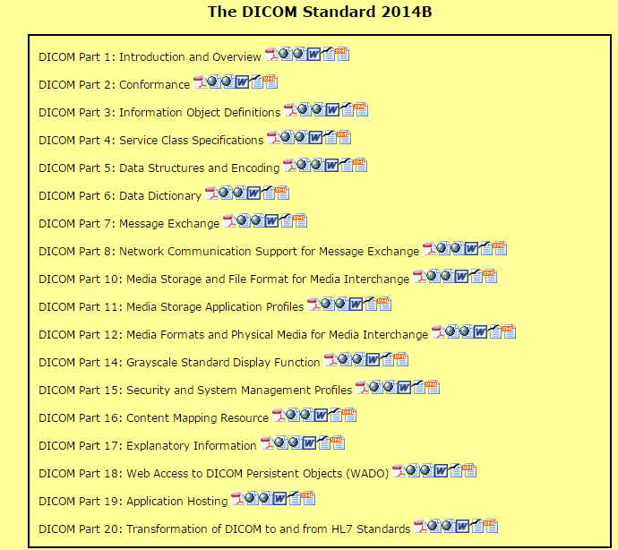

Source: http://medical.nema.org/standard.html

There are different parts in the complete standard which addresses specific part in medical image formation, store, and transfer process. Each vendor will use this as standard semantics to follow while implementing in the product which they develop. If these documentation/semantics followed, there is high chance of full interoperability between these devices to another similarly implemented device irrespective of the vendor.

- MEMBERS of DICOM Standards Committee
    - Manufacturers
    - Users
    - General Interest

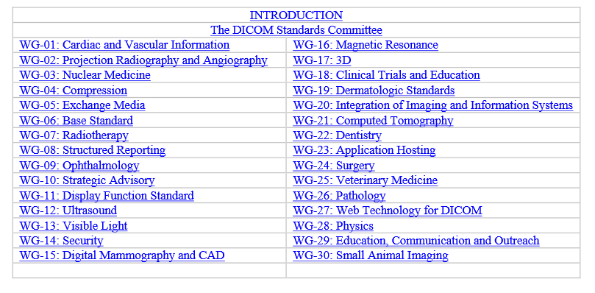
These are the working committees headed by various members’ collect the feedback, brainstorm and come up with proposals/changes in the respective volume number in the standard. This is the beauty of the standard and no vendor is allowed to violate this standard and implement on its own.

How do we know that each vendor has implemented as per DICOM compliant for each part of the standard? The simple answer is to request/refer the vendor product specific DICOM conformance statements. It includes all the information which describes the compliancy according to DICOM standard for each component.

- DICOM Terminology:

  - DICOM Information Model:

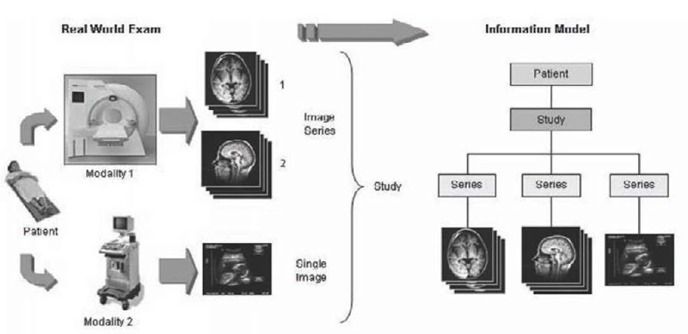

Patient visit will go through one particular visit and that visit creates separate study, in each study, they will create separate series (Scout, different phases, procedures); then, in each series it will have multiple images (taken different intervals, positions) as shown in the above diagram.

As per DICOM information model representation

Patient will have

Multiple Studies (MR/CT/NM) will may (1-n)

Multiple Series (PlanScan, Scout, Phases of Scan, Reports, Rawdata, etc.)

Multiple Images (different Time intervals, positions)

 In IntelliSpace Portal:

In intellispace portal patient directory, unlike Patient level, it will show study level onwards i.e.,,
Studies Series Images. Because, in Radiology as we know that, the workflow be based on studies rather patient level. Multiple studies of the same patient will be one after another in the Patient Directory (PD) and each will be identified by same patient ID with different Study IDs.

It is important to remember the fact that, each visit of the patient will have unique Accession # (Generally created in HIS/RIS) and unique Study_ID (generally created in modality) which will be uniquely identify the study apart from the obvious Study_Instance_UID (which will be discussing in coming sections).
  - Data Representation

    - Attribute:

    - In our DICOM, everything we represent right from Patient Name to image color to diagnosis results also represented in attributes.
    - Attributes also called “DICOM Tags”.
    - Approximately, we have nearly 2000 standard attributes in DICOM dictionary.
    - Attribute is tiny part/lowest level to convey the information.

Basics of Attribute:

    - Tag is collection of 2 items and each item is represented in “Hexadecimal” format.

(Group, Element)

Group: If this number is Even – It is DICOM Public Tag.
If this number is ODD - It is vendor specific Tag.

Why Private Tag? Each vendor despite sharing public information via public tags wants to retain their proprietary information of the applications like for example specific algorithm specific data/logic which helps them to be unique in the competitive market. So, in those situations they will try to use the private tags and it is very common in many vendor applications (especially in MR world), it is fine as long they keep the all valid DICOM fields in public tags.

Example:

- (0010, 0010) – Patient Name - Group Item Number is even.

In ISP - This is how the tag looks (ViewDICOM info).

- (2005, 1414) – PIIM_MR_SERIES_NR_OF_DIFF_B_VALUES – Group Number is Odd.

In ISP - This is how the tag looks (ViewDICOM info) - Philips MR modality private tag.

You can assume this is a kind of variable name in programming language which holds a value during entire
processing of data (store, transfer), users can change the data based on the operation.

So, in each container should be defined some kind of data type to allocate memory and tell what kind of data it can hold.

We call data type of the tag in DICOM world as “Value Representation (VR)”.

VR (Value Representation) should tell data type, length and what are allowed characters allowed/not allowed as per the DICOM standard.

Example from ISP – How to interpret from sample Attribute/Tag

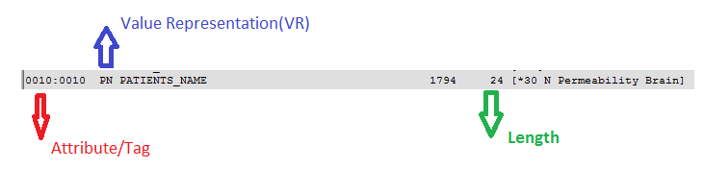

VR – Is two letter word to symbolize particular data type for example PN is like Patient Name
(All Names related value storing purpose PN VR will be used).

Length – Maximum allowed size for this tag. (In DICOM, Length will always in even number, if any odd value is there product will add trailing spaces to it make to nearest even number).

Guidelines/Approach to look for each Tag VR properties like data type, length & allowed characters in the
DICOM Standard.

For any attribute, if you want to find out the “VR”, follow below simple steps.

Step -1: Go to http://medical.nema.org/standard.html

Step -2: Download, Volume number 5 (DICOM Part 5: Data Structures and Encoding) and search for VR
Type and read the details to understand better of each VR type.

For example, if we want to know about PN, this how it looks (snapshot from standard for example view).

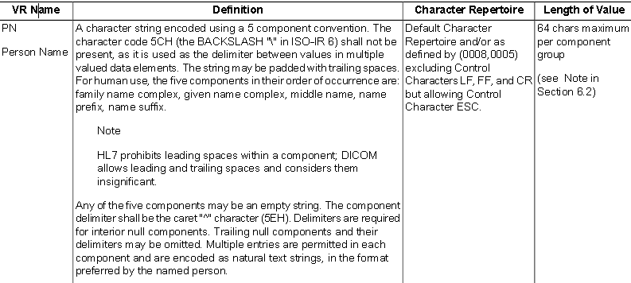

Sequencing Attributes: There is VR representation called “SQ” which means sequencing and it is generally used to represent complex data element representation. Each set in a data element is another DICOM element/tag set. DICOM objects can contain sets of other DIOCM objects. There is recursion or nesting of DICOM objects. Each element is represented by “> “for one level and another level “>>” for sub-level and so on.. While representing in the DICOM elements set. This is very commonly will be seen in enhanced objects/multi frame IOD representations.

Value Multiplicity (VM): It defines, if the tag contains single value of the type or multiple values of the
tag VR type.

For example, below tag Patient Name has the Value Multiplicity (VM) = 1, it means that, this tag can have
Maximum 1 name only.

In the same below tag name Allergies can have multiple values because patient can have multiple allergies so
to accommodate those string values, it is defined as multiple like 2, 3, etc…

Each value is separated by “\” backslash character as delimiter to know it is a separate string.

Note: In the DICOM standard, part 6 – Data Dictionary, for each DICOM tag the VM can be found it clearly.

    - Information Module (IM):

Collection of attributes of some specific purpose/category made as Module. It is first and most essential level of data element organization. For example, the Patient Identification Module (shown below) groups all patient-identifying information like Patient Nam, Patient ID,etc.,.

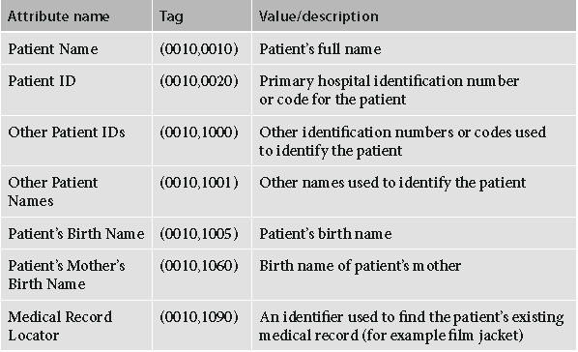

Module will gather related data attributes (elements) in consistent, structured manner.
Each Module which we choose/use can be Mandatory (M) or Conditional (C).

Attribute in these modules have something called Mandatory value.
Each DICOM Tag/Attribute can be defined by their mandatories like for example.

Type | Meaning
1 | Required and non-null
1C | Required based on a condition
2 | Required can be null
2C | Required based on a condition
3 | Optional

How to Find out Mandatoriness of each Attribute in Standard?

DICOM Standard Part -3 i.e., “Information Object Definitions” describes in detail of each module (type of presence) and its attributes clearly.

http://medical.nema.org/medical/dicom/current/output/pdf/part03.pdf

    - Information Entity (IE):

- DICOM Information Entity (IE) is built from Modules (IM).
- Each IE should include module which is relevant.
- Common Study IE includes General Study Module, Patient Study Module, and Clinical Trial Study Module.

Below is the example of various IEs and how they are formed using different group modules.
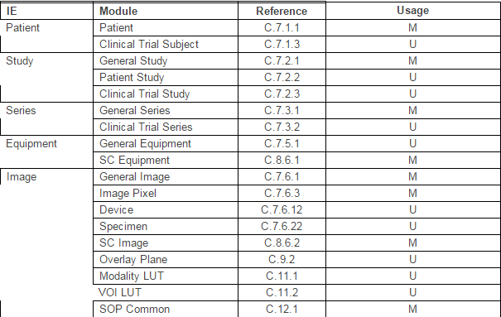

Each Module can be termed as Mandatory (M), User Option (U) or Conditional (C)

    - Information Object Definition (IOD)

Note: This is very important concept to understand in DICOM (Read carefully).

    - Entire DICOM data processing is carried out in systems in IODs and it is mandatory that all DICOM data must conform to the IOD types.
    - Information Object Definition (IOD) is formed from a set of appropriate Information Entity’s (IE) and Information Modules (IM).
    - IODs are used to build common data types in digital imaging, such as various modalities like CT IOD,MR IOD, NM IOD, US IOD, etc.,.

For example, CT IOD, built from IEs and Information Modules (IM).

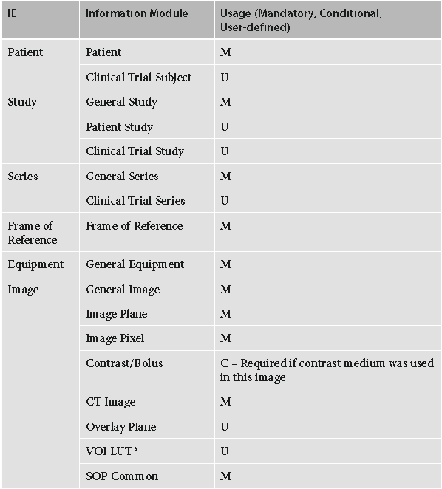

So, each Modality IOD has their specific IEs and IMs based on their imaging technique and matter of
Interest. Each IOD has their own IEs and IMs.

These can be referred in the DICOM Standard –Part -3 “Information Object Definition (IOD)”.

This is one example of Patient details to IOD how it is mapped and represented in DICOM world.

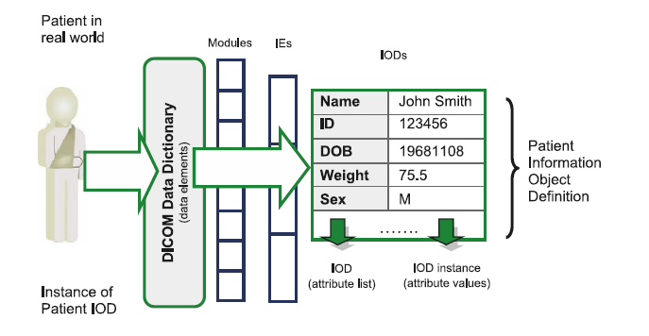

  - Unique Identifiers (UID)

    - As previously explained, Information Object Definition (IOD) can be referred as object in object programing language terminology.
    - Here “object” is nothing but modality data likes for example “CT” Study / MR Study of a particular patient.
    - Assume a case, Patient X has CT study and the radiologists wants to make some annotations/cropped, color-edited or etc.,, the user make a copy of the original and make the modifications on the newly created copy of the study.
    - In DICOM, this is achieved with UIDs – Unique Identifiers.

DICOM uses following UID encoding convention across the industry.

UID = <orgroot>.<suffix>

<orgroot>

The “1.2.840.10008” string is reserved as the universal “<org root>” for all DICOM transaction UIDs, and cannot be used elsewhere.

Like that every organization should reserve their specific orgroot; Philips also will have their orgroot which should have been registered.

<suffix> - It is composed of several numerical components, shall be unique with in the
<orgroot>.

Example, we can build like
<patientID>.<StudyID>.<CurrentDate>.<CurrnetTimein milliseconds>

This way, it will be unique for each study across the enterprise.

It is purely vendor choice to choose any number as long as they are compliant to UID tag rules as shown below.

UID – VR is UI and length is 64 characters.

Note:

- In Philips ISP, each application uses some specific number from each application to make sure that it is consistent across the product releases.
- These numbers are also sometimes plays role in conversions especially for MR Modality like MR Converters internally.

Example Tags which are used are

Study Instance UID
Series Instance UID
SOP Class UID

Sample from ISP application, how these 3 important tag values look

Study Instance UID
Series Instance UID

SOP Class UID

  - DICOM Dictionary

- DICOM Dictionary is kind of registry of all the DICOM attributes which has to be used to represent medical image by any vendor while generating the medical images.
- It defines the Tag Name (Group, Element), VR, VM, and Length which are very key for any vendor to interpret in the same way DICOM standard defined.
- Each vendor will have DICOM Dictionary stored along with product to compare/refer with to check always against these rules.
- In addition to this, we have DICOM private dictionary, despite DICOM has nearly 2000 tags, vendors wants to use specific their own vendor specific tags in the DICOM encoded data.
- So, we have defined that tags as even (DICOM) group number, Odd (Private) group number to identify DICOM tags and private tags respectively.
- It will enable the vendors to create own private tag dictionary with the format defined as per the standard to use while working with their own specific tags.

- For example, DICOM patient name tag doesn’t have Middle Name; so, to accommodate that, vendor can create specific tag of their own in private dictionary and make them used in their product without changing anything in original patient name DICOM tag.

  - DICOM Encoding:

- We know that DICOM objects include DICOM information and
Commands and these objects transfer between various devices across the network.

- We use some basic 27 VR types and sometimes the “SQ” VR type for complex sequence types.

- There some basic rules in DICOM while encoding the information into the DICOM objects so that other product which receives should be able to understand properly.

- Encoding is nothing but, writing the attribute/tag as per the DICOM specific format.

- There are 2 types of encoding

  - Implicit VR Encoding – by default, this format should be used as per DICOM.
  - Explicit VR Encoding -

- As per VR length rules, the length should be always even, if it is even length of any field, we have to add trailing spaces.

Implicit VR Encoding:

For Implicit Encoding, all the multi byte numbers will be written starting from the lowest byte.

For example, (0010, 0010) Patient Name tag will be encoded as per implicit as
Group item 0010, the lowest byte 10 come first and 00 highest comes later and the same logic applies for element part of the tag as well.

Example Syntax of Implicit Encoding:

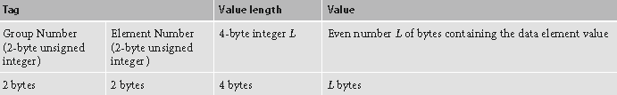

Sample Patient Encoding in Implicit Endian:
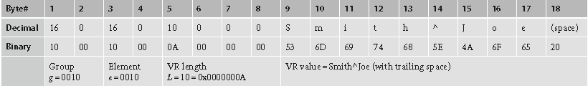

- Multiple data elements are actually encoded in the simply concatenate their individual encodings into a single binary strings.
- Because of fixed group and element length, it will make easy to read each separate element with fixed 4 bytes, followed by length value and content followed by again the fixed 4 byte tag value.

Explicit Encoding:

- Explicit Encoding is similar to implicit.
- It has two sub-types.

1st sub-type:

- It applies to all l VR types except OB, OW, OF, SQ, UT and UN.
- As name tells, explicit VR we include two-character VR type.
- In Implicit encoding is now split into a 2-byte VR type and 2-byte VR length.

Sample patient showing how the encoding does in the Explicit Encoding.

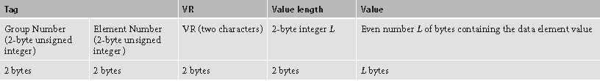

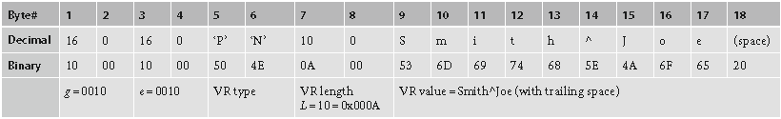

Note: The main difference between implicit Vs Explicit is that, the VR type is included in explicit showing that
what kind of data type which is encoded.

2nd sub-type:

- For VRs with OB, OW, OF, SQ, UT or UN – explicit encoding is done little slightly.
- 2 reserve bytes (set to 0000) follow the VR name and 4 bytes for VR Length (same as implicit).

Below is the example of to encode a pixel buffer for 26 X 256 images with OB type.

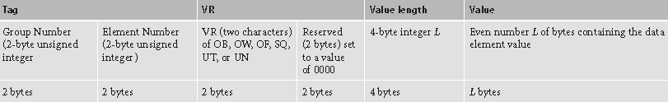

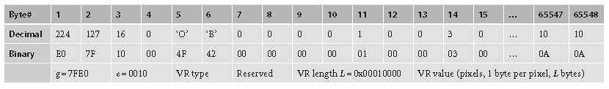

Important Pointers to remember on Encoding:

a. In the same DICOM object, mix of explicit and implicit should not be there at all.
b. Explicit encoding works better than the implicit, because of the fact that redundancy VR types
helps avoid data decoding errors.
c. if any vendor making specific vendor specific tags, it is most important to keep the explicit VR
Specification because the standard DICOM dictionary will have those definitions.
d. Though, the default encoding is implicit with little endian transfer mode for transfer, the two
DICOM nodes still negotiate the encoding /transfer mode before making the actual transfer (This
will be explained in coming chapters).

Note: for every group length tag, it’s first element (gggg, 0000) is reserved to hold the entire length L (in bytes)
of all following gggg data elements present in the given DICOM object.

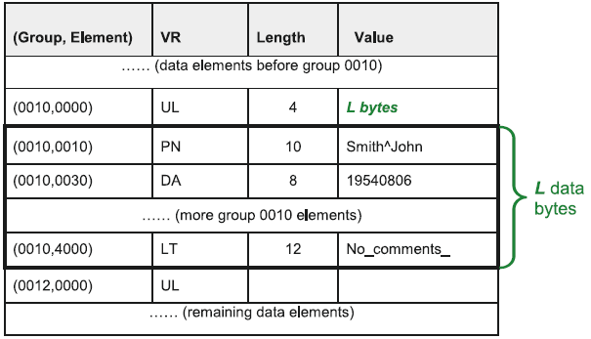

Example:
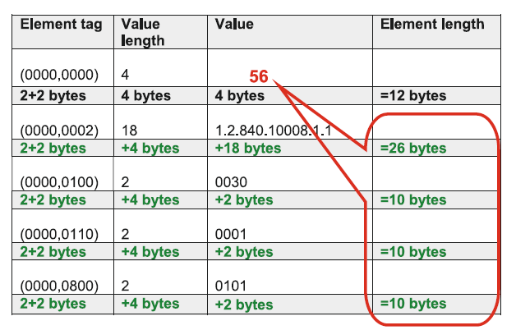

Encoding DICOM object Sequences:

Another important DICOM Object encoding which

- VR type SQ (Sequence), plays very important role in DICOM data encoding.
- It facilitates entire DICOM objects to store in sequence manner.
- It is similar to the concept of book where the each chapter has sub-chapters/sections and so on.

a.DICOM objects in SQ sequences are encoded as sequence items.
b.Each object-item in SQ Sequence in preceded by (FFF,E000) tag ( known as delimitation item).

. Explicit length of the DICOM item – To tell how many bytes to read to get following object.
. Implicit (undefined) length set to hexadecimal FFFFFFFF and marks the end of the DICOM object item
with delimitation item (FFFE,E00D).
c. Similar to item, entire SQ sequence can have explicit or undefined length:

. If explicit length is used, this length is equal to the total length of the encoded DICOM object
Sequence.
. Implicit (undefined) length set to hexadecimal FFFFFFFF.

One sample representation of entire sequence tags graphically

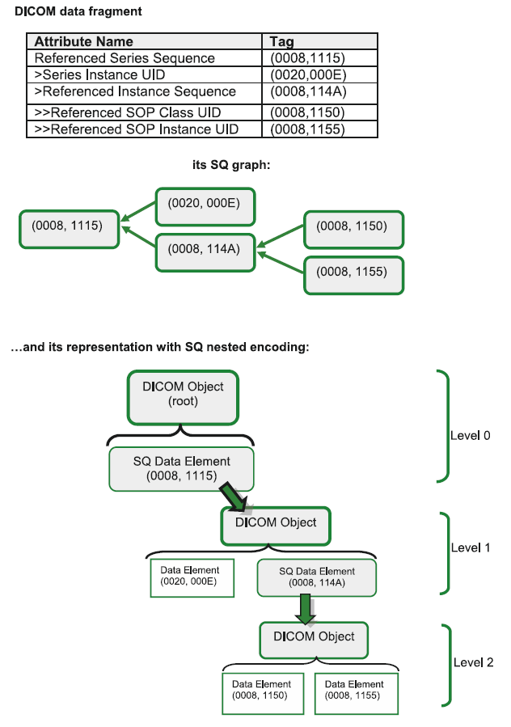

- DICOM Network Communication:

- One of the important things in hospital workflow the medical image data has to transfer
In various touch points in the hospital.
- As you know, DICOM standard plays vital role in making it happen smooth and seamlessly to transfer across different products and more importantly from different vendors.
- DICOM makes the rules and semantics to transfer between two devices is very key for each vendor to implement the same to comply standard.
- From support perspective of any DICOM compliant product, it is important to understand the standard and what goes in / comes out and how this is communicated internally plays a vital in understanding the issue and help to resolve the issues in the field.

So, my personal to you all play very key interest in understanding these concepts,
because these won’t change and more beauty is that it is a skill which will be used across
any DICOM compliant product.

4.1 DICOM and OSI Basic Reference Model:

- To transfer the studies to another product via network, medical equipment software builds/refers to OSI Basic Reference Model.
- DICOM uses OSI Upper layer service to separate the exchange of DICOM messages at the Application Layer from the communication support provided by lower layers.

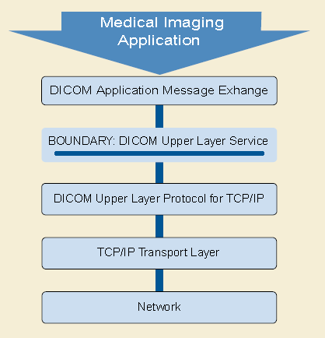

- This OSI upper layer service boundary allows peer Application Entity (AE) to establish associations, transfer and terminate associations.

- For this reason, DICOM has adopted the OSI standards (Presentation service argument by the Association Control service Element).

DICOM Application layer is shown below (don’t feel scary if you don’t understand now, we will talk about each in coming sections).

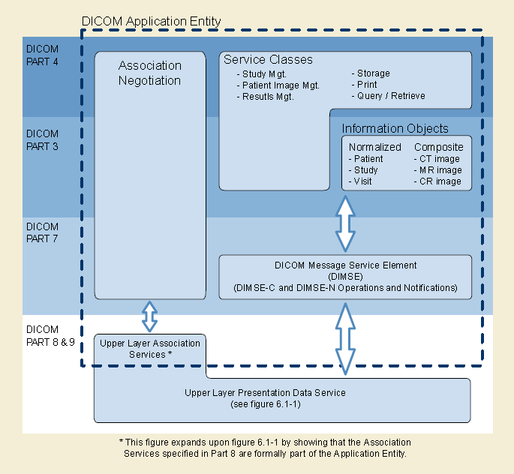

Let’s set the stage by discussing each items required for communication

Application Entity (AE):

- It is also referred AE Title (AET), DICOM AE.
- It refers to DICOM application service which responsible for communicating to another device under network via DICOM communication method.
- AE title can be upto 16 characters long.
- It is a case sensitive string.
- VR for AE title is “AE”.

IP Address:

- Each application having Network Interface Card(NIC) / Network card should have the IP address to communicate to other device.
- It is a four octet number separated by. and usually hospital IT provides before/during implementation.

Port:

- In network, the actual data transfer by TCP/IP uses port on each computer once they are reachable via IP address.
- Ports are numbered from 0 to 65,535.
- DICOM default port is 104.
- Always very careful in choosing the port numbers (because some ports like 80 will be used by other applications, always discuss with local IT, product experts before choosing) – That could be best to leave it default whatever product gives.
- Sometimes, in same computer different DICOM services/applications are running, they will choose specific port each service.
- Some of the AET have dual port i.e., same AET can have one port for receiving and another for sending.

4.2 DICOM Service & Data - SOP

4.2.1 SCU (service Class User) & SCP (Service Class Provider):

- Each AE in application provides the “service” to other AE of another application.
- Suppose for example Application AE1 asks the requests the service to AE2.
- In DICOM lingo, system (AE) which asks the request is called “User” and system (AE) which provides the service is called (Provider).
- It is so simple to relate with Client /Server model, client is one which asks certain request like get the webpage to the server so, it is called User in our context and server which provides webpage to client is called “Provider” in our context.
- DICOM is always represented in Object oriented world as it is related to real word transactions of the problem.
- Everything we represent here in-terms of Classes.
- Service Class User (SCU) and Service Class Provider (SCP) is very basic terms should be
- Understandable before analyzing the any scenario.

Tip to L2/FSE: a) before looking into the problem, always understand first who is SCU and SCP in the DICOM
Scenario that you’re going to troubleshoot.
b) Jotting down on the paper which one is SCU and SCP based on scenario would be nice way to
Learn actually initially until getting used to it.

For example, consider IntelliSpace Portal scenarios and how to identify the SCU/SCP roles.

Example -1: CT scanner pushing to the Intellispace Portal.

SCU: CT scanner.
SCP: IntelliSpace Portal.

Example-2: Intellispace Portal query/retrieving the studies from PACS.

SCU: Intellispace Portal
SCP: PACS

Role (SCU/SCP) capabilities in IntelliSpace Portal:

- IntelliSpace Portal, being a diagnostic workstation, considers supports SCU & SCP or only SCU or SCP depends on each the service.

- The best to refer, which service ISP supports SCU & SCP role for each supported service can be found in the “DICOM Conformance statement” in InCenter for each product version.
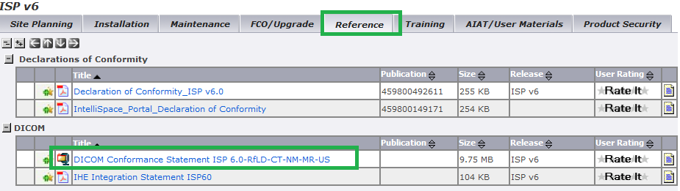

4.2.2 Service Object Pair (SOP):

Object: As we discussed in chapter 1 that, object is nothing but the IOD here like for example CT IOD, MR
IOD, NM IOD, US IOD – it is medical image.

Service: Service nothing but a commands/operation to be happened on the object and it also called “DIMSE” in
DICOM lingo. Services could be store, query, retrieve, verification, print, modality work list,
Performedprocedure step.

Pair is word used because; it is pair of service + Object.
Generally, it is referred as CT SOP Class, MR SOP Class, NM SOP Class, US SOP Class.

Class is word used to represent that DICOM is object oriented concepts.

So, definition of a Class tells that, Data and operations on the data.
Here in DICOM SOP Class lingo, Data – Object; Operation- Service (Store, Query/Retrieve, Print, Verification).
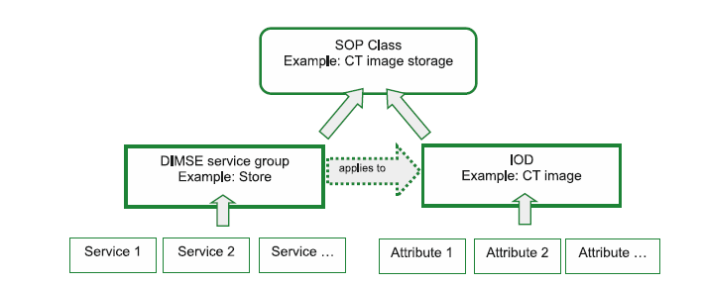

- Each SOP Class will have it’ UID number which uniquely represents.
- For example Verification SOP Class has below unique number.

SOP Class name - Verification
SOP Class UID - 1.2.840.10008.1.1

If we look at the above diagram, it represents the CT Store SOP class = Store Service + CT IOD.

4.3 DICOM Services - Basics:

4.3.1 Verification:

- This is basically verifies DICOM connectivity between two AEs.
- Each SOP has certain DIMSE commands which are being used to communicate between 2 DICOM devices.
- For example for verification C_ECHO command with C_ECHO_RQ and C_ECHO_RSP.
- Like for example, ISP wants to check the verification SOP to PACS, it sends C_ECHO_RQ and the PACS responds with C_ECHO_RSP.
- It’s simply asks, “Can you talk DICOM to me” and hopes to hear “Yes”.
- If the Verification SOP fails, it could be 2 reasons

  - Either Physical network is down
  - Network is okay, AE title/Port level miss-matches between 2 devices, checking between two devices between AE, Port, and IP address aspects.

 In ISP – Verification SOP:

In ISP, we can perform the verification test couple of places

- ISP should support “Verification” SOP as both SCU and SCP.
- In the Patient directory, choosing the device and click “Verify Connection”.

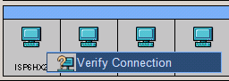

You will get below message which confirms that verification service is working fine.

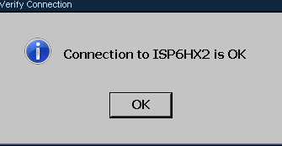

- In the LAN Configuration, choose the DICOM Node of interest and click “Run Connection Test”

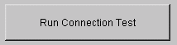

You will below message which confirms that verification check with status “Passed”

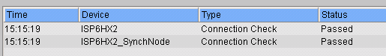

Note: I have used another ISP server and the process is same for any DICOM node (Scanner/PACS).

- It is primary most important check to do as first priority check before digging into the DICOM connectivity issue on any node in detail.

4.3.2 Store:

- This is very very important and main medical image intensive service, Store service.
- The DIMSE command used for this purpose is C_STORE.
- In DICOM communication, after C_ECHO(verification) is passed, SCU transfers studies
to SCP via C_STORE command DIMSE command.

- People generally confuse the store service with many IODS like CT, MR, NM, US,etc.. Image store.
- Actually, different objects having different processing, for each modality IOD, there is separate Storage SOP Class UID was given to uniquely identify in the communication.

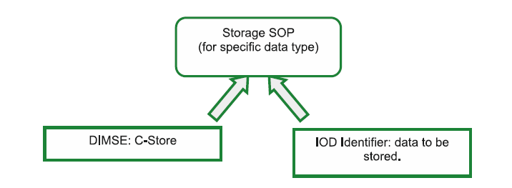

- C-STORE DIMSE is very much modality-independent.
- The IOD/modality could be different for based on type of images like images, waveforms, reports and more.
- In a study, for each image C_STORE performed to send to the destination node.
- For each C_STORE_RQ of the image, the SCU expects response from the SCP, as C_STORE_RSP with Status tag value usually 0000 means pass, FFOO (pending) or error specific to what modality sends.
- Image types generally will be single frame and multi frame kind of images.
- Transfer also can be referred as synchronous transfer and Asynchronous transfer.
- Synchronous transfer means, if for example CT study has 500 images, for each image it sends C_STORE_RQ and waits for the C_STORE_RSP to arrive from SCP before sending the another C_STORE_RQ for next image.
- Where as in Asynchronous communication, C_STORE_RQ will keep sending and it doesn’t wait for C_STORE_RSP only and it increases transfer speed of the transfers, however; more importantly, the Support is depending on the SCP.

 In ISP for each version of release, we keep adding modality support; the only official place showcase is the “DICOM Conformance” document which tells which storage SOPs supported and role support also mentioned.

http://incenter.medical.philips.com/Default.aspx?tabid=4539&itemId=8848&LLClassId=9834443



Refer Table -1 Network Services

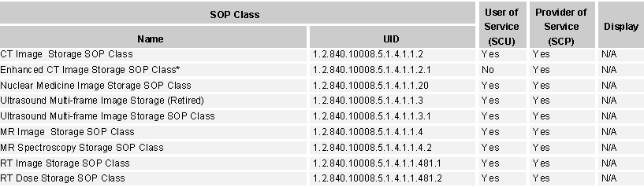

For Example, if you see Enhanced CT Image Store we accepts as SCP only and we can’t send the in the Enhanced CT format (* because we convert internally to classic and we never store the enhanced CT object).

Any Scanner and PACS Vendor should refer to this and understand its capabilities.

Tip L2/TSE: During troubleshooting also, sometimes we see specific study/series is failing in queue manager either by Query/Retrieve or Prefetch operation; it is worth to take the SOP Class UID of failed series and search in the conformance statement of the release version and look support in SCU/SCP based on the use case, if it doesn’t listed here, would be faster to move to next step in the troubleshooting process.

4.3.3 Storage Commitment:

- After Storage operation is successfully performed to SCP, from SCP we don’t have guarantee that, it is stored the data completely and takes the ownership of the data with C_STORE operation.

- Consider case, modality especially in E-R does many scans per day and it has limited storage, it can’t keep the data for longer duration; so, we need a mechanism to store the data permanently and takes the ownership of the data, if that happens, the scanner/modality can delete the studies from its local machine.

- Storage commitment SOP class transaction will provide the conformance that all the studies which are stored are completely stored.

- After store is performed, the SCU will ask explicitly for each image like did you store this image in the DB and takes ownership?

- Then, the PACS respond for each image it is stored permanently in the archive, saying that it sored completely.

- The confirmation can happen in either synchronously in the same association or in asynchronously in separate association especially if the PACS is busy and it does the confirmation offline during off load times; during those times, PACS prefers the Asynchronous mode where in separate association is opened separately. Usually, this is configurable item in most of the PACS which it supported.

- Generally, while pushing the studies to PACS, it is always recommended to use the storage commitment to make sure that all the images stored permanently and took the ownership.

 In ISP, Storage commitment is supported as SCU only, i.e., while transferring to any DICOM node we can request the Storage commitment.

As SCP we don’t support, which means that Intellispace portal doesn’t take the ownership of the data for longer storage because of the fact that, we are not the archive solution.

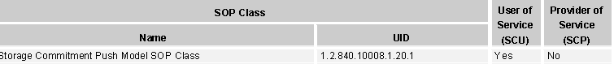

4.3.4 .Query/Retrieve:

It is one of the important service for intellispace portal in general because the same service used in normal Query/Retrieve, Prefetch operation (automatically), we will learn in detail.

Let’s learn each part of the service separately (Query (Find), Retrieve (MOVE)) and combine at the end.

Query: It also referred as FIND and termed with DIMSEcomand C_FIND.

DICOM divided C_FIND search into 3 levels: Patient, Study and Patient-Study and each level of search has it’s own UID.

SOP Class name SOP Class UID

Patient Root Q/R Find 1.2.840.10008.5.1.4.1.2.1.1
Study Root Q/R Find 1.2.840.10008.5.1.4.1.2.2.1
Patient-Study Root Q/R Find (Retired) 1.2.840.10008.5.1.4.1.2.3.1

So, we left with only, 2 as Patient-Study Root Q/R is retired now.

SOP Class name SOP Class UID

Patient Root Q/R Find 1.2.840.10008.5.1.4.1.2.1.1
Study Root Q/R Find 1.2.840.10008.5.1.4.1.2.2.1

As you know, in ISP we support from only, Study level, we end up by supporting or requesting Study Root Q/R Find (you can refer the same in DICOM Conformance statement).

Because the current radiology workflow is study-centric, the Study root is the most widely supported in
DICOM applications and is usually always provided by default.

To search, we need C_FIND command and search criteria for DICOM Node to search and give the results based on that.

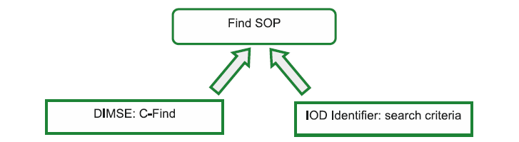

Search Criteria:

When C_FIND SCU sends a query with DICOM fields, it includes a set of attributes to be matched at the SCP.

While specifying the search criteria in the DICOM fields, we have ways to specify the search values

a.Wildcard matching:

- * and ? are two wildcard characters can be used for string related searches.
- * for multiple character searching and ? is for unknown single character/symbol replacement search.

b.List Matching:

- Technique uses blackslash (\) wildcard, which means “or”.

- “Venkat*\Goud” – It will find either Venkat or Goud words in the SCP in given DICOM field.

c.Universal Matching: if nothing is specified, it will match everything.

d. Range Matching:

- This for attributes having ranges, such as date or time. It will have start and end
Which is separated by “– “.

- For example, range date match 20060626-20141206 means any date between June 26, 2006 and
December 6, 2014.

e. Sequencing matching:

- This is mainly used in DICOM Modality WorkList (DMWL) query requests; it is bit complex search matching. It is formed with Sequence of attributes (SQ VR type). For example, matching a modality scheduled patient study, patient ID, and study date and accession number.

f. Single-value matching:

- This simply, searching with exact value as matching parameter.
- Like for Patent ID, UID specific searches the single-value matching is used.

Very Important Node /Tip for L2/TSE in troubleshooting Query related issues at ISP:

Most of the attributes in these FIND may be required or optional. Before looking for specific values issues of query/C_FIND, search in the product specific DICOM conformance statement and it tells which values it is optional (O) or Required (R)

Searching with value which is optional at the SCP doesn’t fetch the exact value as response and instead it may give all the results which causes the issues or takes us to wrong direction.

For example, in iSite PACS/ IntelliSpace PACs, DICOM conformance statement. It mentions which attribute are option and required.

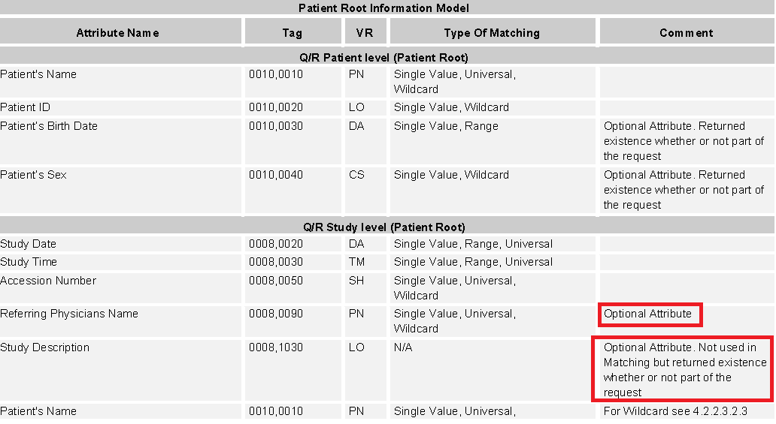

It says, searching via Referring Physicians Name and Study description is optional as C_FIND SCP at the iSite PACS side, we when C_FIND SCU tries to query based on that, it may not give only the result based on that search, it may give all the studies.

Similar way, IntelliSpace Portal acting as C_FIND SCP, when anybody queries, we have some Option and Required attributes and it can be found in the DICOM conformance statement.

Also, sometimes the field values may be case sensitive in searching and returning the results and it’s depends on the PACS. Preferably, it would be nice to have in-case sensitive so that it will results to the SCU as long as it is correct word (irrespective of upper or lower).

Understanding the C_FIND request IOD

This is very key to understand and it helps in troubleshooting the query related issues a lot.

Some of the DICOM tags are very important to look during the C_FIND_REQ command.

- (0008,0052) –Query Level - Values can be PATIENT/STUDY/SERIES/IMAGE

In ISP, we support from Study level, it can be either STUDY/SERIES/IMAGE

Based on the query level, the respective level DICOM attributes can be searched for in the SCP

- (0000,0002) - Affected SOP Class UID: Patient/Study/Patient-Study

In ISP it will be all ways - 1.2.840.10008.5.1.4.1.2.2.1 (Study)

- Status (0000, 0900) - 0000 (Success) / FFOO (if Pending) / other values if warnings or errors.

At ISP, In addition to this in C_FIND_RQ we also see the query submitted DICOM attributes (in DICOM logging by keeping MXLLayer=Debug) for verifying the values. Alternatively, all this tags can be referred in the iWatt Tool (which will be discussed in detail later) by default.

Retrieve /C_MOVE:

Once the C_FIND get the results display in SCU and if those patient/studies/series has to be copied into SCU locally, we have to use the service called MOVE with C_MOVE_RQ with what patient/study/series and where to push (AE title).

As part of C_MOVE operation, the C_MOVE SCP will submit the C_STORE_RQ to the AE title which was given as part of the C_MOVE_RQ.

It is something like ,C-Move looks more like me calling you on a phone and asking you to call our friend John. Now you need to find out what John’s number is and whether you can call him. In DICOM terms, you need to open another association to speak with John. Many bad things can happen to you during this intricate task. You might not find John’s number, or you might dial
a wrong number.

SOP Class Name SOP Class UID

Patient Root Q/R Move 1.2.840.10008.5.1.4.1.2.1.2
Study Root Q/R Move 1.2.840.10008.5.1.4.1.2.2.2
Patient-Study Root Q/R Move (Retired) 1.2.840.10008.5.1.4.1.2.3.2

Same like, C_FIND, In ISP we support only Study Root Q/R Move SOP class only.

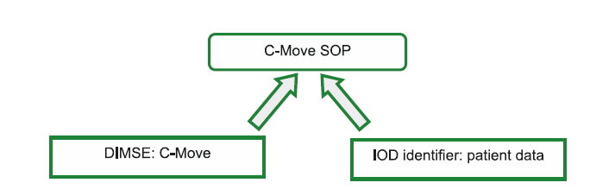

Important DICOM tags, we look as part of DICOM C_MOVE transaction is

DICOM Tag | Name | Description
(0008, 002) | Retrieve Level | STUDY (Can be Patient/SERIES/IMAGE).
(0020, 000D) | Study Instance UID | Study Instance UID value which is being requested to copy.
(0000,0600) | Move Destination | Shall be set to the DICOM AE Title of the destination DICOM AE for which the C-Store sub-operations are performed.
(0000,0900) | Status | 0000 (if successful), FF00 (if pending), or other values  For warnings and errors.
(0000,1020) | Number of Remaining Sub  Operations. | The number of remaining C-STORE sub operations to be  invoked for this C-MOVE operation.
(0000,1021) | Number of Completed Sub operations. | The number of C-STORE sub operations invoked by this C-MOVE operation that have completed successfully
(0000,1022) | Number of Failed Sub operations. | The number of C-STORE sub operations invoked by this C-MOVE operation that have failed.
(0000,1023) | Number of Warning Sub operations. | The number of C-STORE sub operations invoked by this C-MOVE operation that generated warning responses.

4.3.5 Modality Work list (MWL):

- Generally, when modality technologists come to work, they really want to know current patients to be scan for the day and it is kind of their worklis for the particular modality.

- Getting the work list from the scheduling information system typically RIS (Radiology Information system) is nothing but MWL SOP does.

- It preloads the patient and scheduling data into the modality and it is beginning of any DICOM Workflow.

- But, in IntelliSpace Portal being a diagnostic workstation, you may be wondering how come we use the MWL in our product and what is the purpose right?

- Let me explain the same

- From ISP 5.0 onwards, we have feature called Prefetch – which is nothing but pulling the priors from archive solutions based on certain meeting criteria.

- As part of that, we have one way of automatically pulling priors, based on the future patient scheduling information from RIS by performing DMWL.

- So, from ISP we can request for DMWL and get the patients scheduled for example for Tomorrow and get that patient priors of last 5 years for example into the Intellispace Portal automatically before patient comes for current state scan and it will enable the radiologists to start the diagnosis/results comparison and no need to wait for anything else.

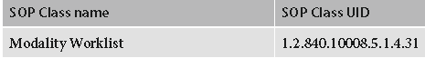

MWL IOD

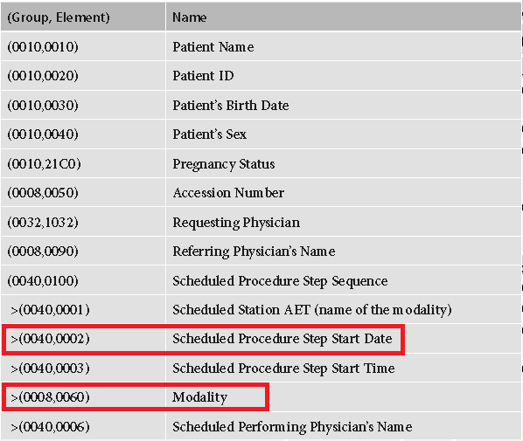

ISP Prefetch – MWL uses these two DICOM attributes to send the request to RIS for getting the patients scheduled for (Scheduled Procedure Date and/or Modality).

- DMWL uses the same C_FIND DIMSE like in Query service and only the SOP Class UID is of MWL and
Remaining everything is same.

- RIS will respond with C_FIND_RSP with all the patients scheduled for particular date/time and
modality for scans.

4.4 DICOM Association Terminology:

We will discuss the entire DICOM association’s related terminology and try to relate all the theoretical aspects with intellispace portal with DICOM logging which helps in understanding faster.

4.4.1 Association Establishment:

- SCU / Association requesting (calling) AE builds and sends an A-Associate-RQ message.
Requesting the receiving (SCP/Called) AE start an association.
- The receiving AE looks all the proposed communication parameters, picks the most appropriate, and replies with an A-Associate-AC message if association is accepted.
- If none of the proposed communication parameters accepted, it will reply with an A-Associate-RJ message, rejecting the association.
- It could also A-Abort message anytime during the association time due to any reason.

4.4.2 Abstract Syntax:

- Abstract syntaxes encode SOPs in A-Associate-RQ while sending to the SCP.
- SCP reads those and tries to acknowledge whether it accepts in communication or not.
- They describe the services that DICOM applications can render to each other.
- we know, that each SOP has got the instance UID, In the Abstract Syntax, each SOP Class UID has name like for
example, “MR Image Storage”, “CT Image Storage”, “Modality Work list”.
- So, Abstract Syntax UIDs, viewed as code names for DICOM networking functions.

For example, Verification (1.2.840.10008.1.1), if we want to communicate from Device A to Device B, device A sends Verification (C-Echo) messages to device B and device B responds like yes, I can talk to you A.

Simply.

A: Do you support/talk Verification (1.2.840.10008.1.1) ?
B: Yes, I support Verification (1.2.840.10008.1.1).. Talk over

Each DICOM application/product will have built-in list of supported Abstract syntaxes with role (SCU/SCP) support.

This can be referred in DICOM conformance statement of that respective product.

In IntelliSpace Portal DICOM conformance statement as well, you can find the listed of SOPs supported. It is very important to always keep this document handy and it will really help in discussing with customer during implementation calls and also especially during troubleshooting.

Below is the general mechanism between Association –RQ and Association –AC between any two DICOM devices the Abstract syntax mechanism works in general terms.
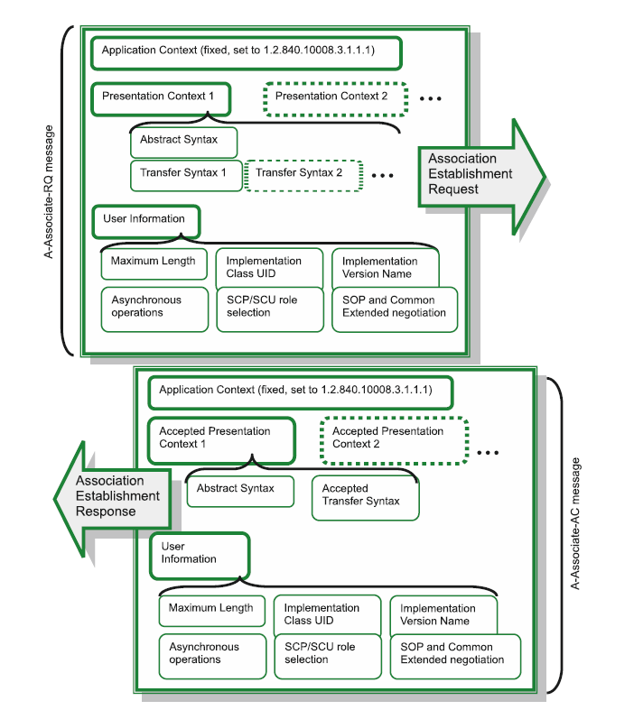

4.4.3 Transfer Syntax:

As we discussed in previous section, Abstract Syntax decides what functionality, the Transfer Syntax, as its name suggests, decides the format of data to transfer between two devices.

As per DICOM standard manual (Part-05), Transfer Syntax means.

A Transfer Syntax is a set of encoding rules able to unambiguously represent one or more Abstract Syntaxes. In particular, it allows communicating Application Entities to negotiate common encoding techniques they both support (e.g., byte ordering, compression, etc.).

So, Simple terms, Transfer Syntaxes explain how the transferred data and messages are encoded.

Before we move on further, let’s read some history of computer storage representation across different platforms.

Different computer systems use different byte orders to represent the same multibyte number.
There are two byte ordering mainly.

A.Little Endian Order (MS Windows OS) – Recording numbers from Least Significant Byte (LSB).
B.Big Endian Oder (Mac / Linux OS) - Recording from Most Significant Byte (MSB).

For example, what a Little Endian computer (MS Windows OS) stores in byte (binary) format as 0x007F, a Big Endian computer (Mac OS) would keep as 0x7F00, reordering the 2 bytes.

When these numbers travel between the systems with different Endian types (for example, when you send a DICOM image from Mac OS archive to a Windows OS workstation), their Endian types must be properly converted (byte order reversed), otherwise the numbers will be read backwards, resulting in totally incorrect values: 0x007F = 127 and 0x7F00 = 32,512.

To avoid data transfer errors, DICOM applications always keep track of their Endian types, and any two connected DICOM units agree on the choice of Endian type during the initial network handshake between them before they start transmitting any data (To make this agreement always possible, DICOM reserves Little Endian as its default byte-ordering type, meaning that all DICOM applications, whatever systems or hardware they are running on, must understand and process Little Endian byte order.

Default transfer syntax as per DICOM is Implicit Little Endian (ILE).

Below are the lists of some transfer syntaxes uncompressed (first 3) and compressed transfer syntaxes.

In Intellispace Portal, we use internal transfer syntax to communicate across Philips CT Scanners/ EBW X.X/ EBW NM x.x / any other Portal versions to transfer faster and avoid conversion issues.

It is called Private –Explicit Little Endian (P-ELE) (also called CT-private-ELE) – It is native format our internal storage mechanism of our platform.

Name Transfer Syntax UID

CT-private-ELE - 1.3.46.670589.33.1.4.1

Apart from that, for each Abstract Syntax/SOP, there are certain Transfer Syntax supported (role wise), it is worth to refer during troubleshooting any modality specific transfer failure or issues.

Some sample Transfer syntaxes and meaning

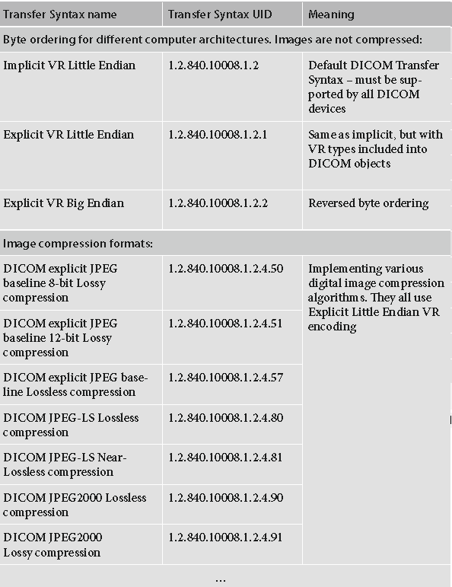

4.4.4 Presentation Context:

It is just a combination of Abstract Syntax (SOP) + Transfer Syntax.

If we relate to general example.

If two partys/teams to discuss on one agenda item/topic (Abstract Syntax in our lingo), they can propose to other party to talk in different languages like English, French, Dutch, etc. (Transfer Syntaxes in our lingo) and receiving party chooses one particular language (one particular transfer Syntaxes).

General Presentation context proposed syntax is shown below.

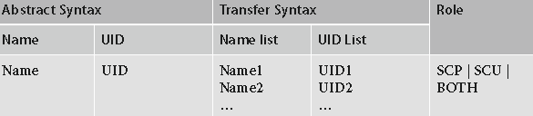

Example -1: SCU AE device proposing verification SOP class to SCP AE devices with ILE and EBE transfer syntax formats, and based on SCP capabilities it choses either one ILE or EBE or both.

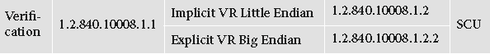

Between two AET, the presentation context communication happens in this fashion after receiving the presentation contexts from source (as shown above table)

Step –1: Abstract Syntax Support: Checks all the proposed Abstract Syntax, whether it matches its functionality
like Abstract syntax (SOP) Class is supported or not, if that SOP/Abstract
syntax is supported it accepts first.

Step -2: Selection of Trasnfer Syntax: Once we received all the various transfer syntax supported for each
SOP/Abstract syntaxes, device choose the supported transfer syntax
based on the capability of the device.

Once this process is done, the SCP informs the SCU whatever has been chosen for the proposed presentation contexts. Here the Presentation context ID number and Reason value values are key in informing this message back.

During troubleshooting/support activities, below reason numbers would be very handy to understand.

Reason – 0 – acceptance.
1 – user-rejection.
2 – no reason: provider rejection.
3 – (abstract-syntax-not supported; provider rejection).
4- (Transfer-syntaxes-not-supported; provider rejection).

Reason number # 3 and # 4 are very important to understand like reason # 3 tells that SOP Class doesn’t
Support by the destination and # 4 is transfer syntaxes is not supported.

4.4.5 Protocol Data Unit (PDU):

- The DICOM communication data objects to communicate /transfer across devices.
- These structures are called “Protocol Data Unit (PDUs) and these are very core part
Of the entire communication.
- Below are various PDUs in various transactions.

- A-Associate-RQ PDU: requests DICOM association.
- A-Associate-RQ PDU: accepts DIOCM association.
- A-Associate-RJ PDU: rejects DICOM association.
- P-Data –TF PDU: transfers a block of DICOM data.
- A-Release-RQ PDU: requests association termination (release).
- A-Release-RP PDU: responds to an association termination request (release).
- A-Abort PDU: aborts any invalid association.
Each PDU has its own information in the transaction it carries and sends across to other peer device AET. (These can be viewed in detail using the iWatt Tool).

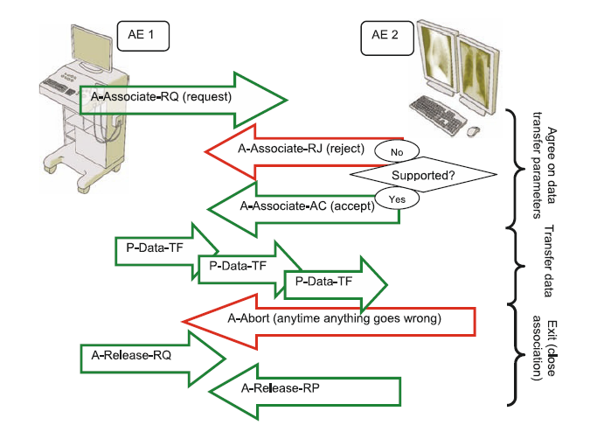

4.4.6 Practical Example:

 Let’s look into the ISP DICOM logs and iWatt Logs to understand better on these theory aspects in
Practical’s which helps in our day-day support activities.

Example: I have captured the Query/Retrieve Logs for sample scenario and captured the logs, check the logs to
Understand all the aspects in both server logs and iWatt (Recommended way from ISP 6.0 version
Onwards).

In ISP – Logviewer:

Note: Make sure keep the MXLLayer=Debug in the log configurator at the server – Refer Section for procedure.

Query (Find) Logs Understanding

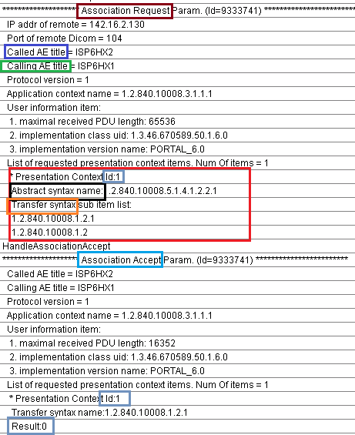

This is association logs of C_FIND (Query or Find) association transaction between 2 devices.

Called AE title is nothing but the SCP AE title.
Calling AE title is nothing but he SCU/source AE title.

In the association opening time, it is proposing the presentation context with single abstract syntax (Study level Find) with all the transfer syntaxes with Presentation context # 1.

The SCP(Called AE) chosen only AE title which it would love to communicate with SCU and confirmed with that result as “0”

Hope it makes clear the find association part in the Find/Query logs section.

Next, comes with actual query which we send to SCP.

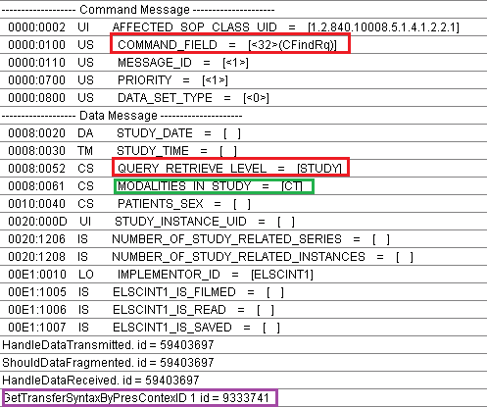

This is part will vary depends on the query which we send to the SCP.
In this example I sent, study level query all CT studies to display.

- It will display the C_FIND_RQ command.
- It displays at which level query sent – STUDY.
- The actual query attributes with values.

Some values like Patient Name won’t display in the logs due to patient privacy and safety, we are not supposed to capture the patient names (we have intentionally disabled in PHI tags) – This can be seen in iWatt logs.

Once the SCP starts giving the responses, it will be display below log.

For each study response from the SCP, it will display the logs in ISP and it will display the details of the study with few tags info.

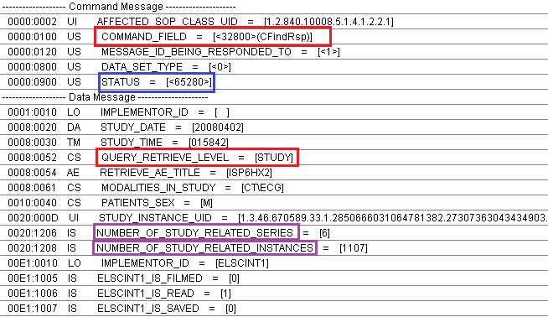

- CFindRsp will give the each study if it matched the C_FIND_Rq command.
- STATUS – This columns tells that there are more studies coming below which matching the criteria.
- For each study it results, it displays some values as patient details like Gender, number of Series and number of images.

Note: Some PACS/DICOM Nodes doesn’t support the values giving and it will be empty

Once all the studies are displayed from the SCP, it displays final C_FIND_RSP with STATUS =0

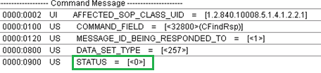

If you try to put the filter in the logs with Query in the Text box, you will see Query started and completed with time stamp

It will help in understanding the problem better just in case.

ISP can also do the same level of query in SERIES level and IMAGE Level and each response will responded by SCP with different level of tags. But, the mechanism as a start works is the same.

Next part is Retrieve/ Move operation.

The association and negotiation for MOVE service from two devices are given below in logs

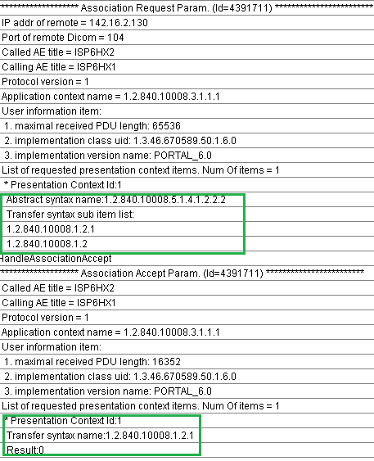

C_MOVE Study level with ILE and ELE proposed and ELE mode is accepted by SCP as per above logs.

Once, the user is submitted the retrieve or move operation on the particular study.

The C_MOVE or retrieve logs going to be like this below.

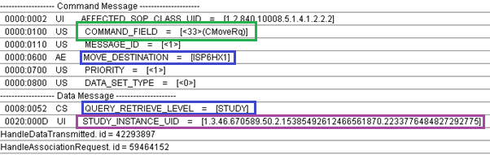

When the study is submitted for the transfer, it will also provide which AE title it has to send the data.

MOVE_DESTINATION is tag which tells the information.
Based on move level, it will pass the parameter to get the data.

QUERY_RETRIEVE_LEVEL= STUDY.

To tell the SCP, which is the study to send, it provided the STUDY_INSTANCE_UID = value of the study.

Immediately after this, the SCP opens up the C_STORE operation to the MOVE_DESTINATION AE title system to send the study requested.

The store logs will be same as general like C_STORE and after every image is sent the C_MOVE_RSP also will inform what the status of copy operation is.

Below are the logs showing Association Request and Association Accept messages in below logs.

In Association request, the SCU proposes all the Abstract syntaxes it can send with all the possible transfer syntax with presentation context Id. Once the SCP validates each presentation context with possible transfer syntaxes, replies with association accept messages with Result value.

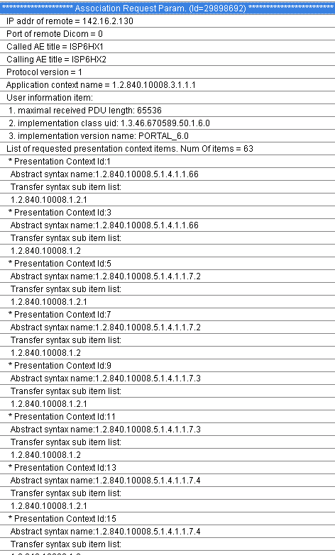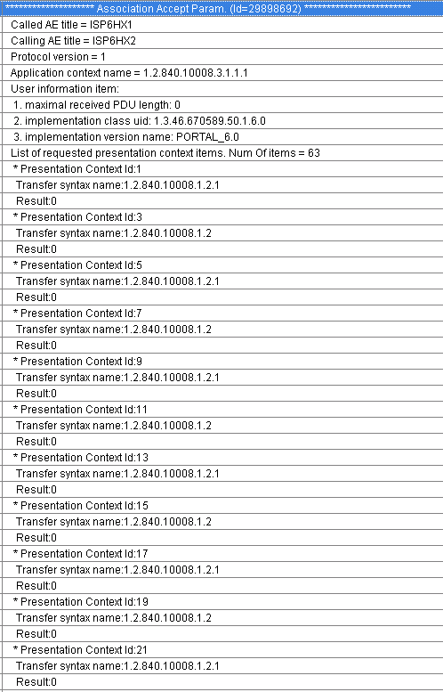

Now, you may be wondering, out these many presentation contexts accepted by SCP, which one is actually chosen for sending particular study

So, here is how we can find out by looking at the C_STORE_RQ message log as shown below

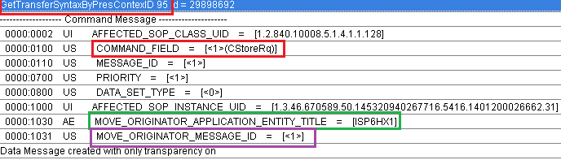

GetTransferSyntaxPresenationContextID: Number
So, by looking this number in the Association request and Association Acceptance message, we can find out the
SOP and Transfer syntax it is sending.

What the image it is sending can be found out by AFFECTED_SOP_INSTANCE_UID.

Next 2 commands which are important, it only shows during C_MOVE Operaton.

MOVE_ORIGINATOR_APPLICATION_ENTITY_TITLE = AE title to which the data has to send.
MOVE_ORIGINATOR_MESSAGE_ID = Number

This number is very important to track the transfer /progress from the C_MOVE_RSP command to see that all are transferred properly and update the user about the progress about the transfer percentage.

Once store is completed as part of C_STORE_RSP with status having 0 means, it successfully transferred.

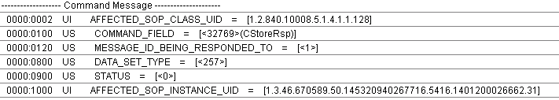

After that, C_MOVE_RSP will be provided to know the current status, that log will be shown

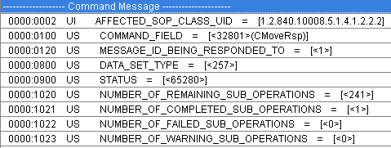

STATUS = Gives the number showing in progress.
MESSAGE_ID_BEING_RESPONDED_TO = it shows the same number which was created in the C_STORE_RQ for
Keeping track of the image transfer in the C_MOVE_RSP.

NUMBER_OF_REMAINING_SUB_OPERATIONS = Total number of images still to be sent.
NUMBER_OF_COMPLETED_SUB_OPERATIONS = Number of images sent across.
NUMBER_OF_FAILED_SUB_OPERATIONS = Number of images failed.
NUMBER_OF_WARNING_SUB_OPERATIONS = Number of images got warning while sending.

Once, all the images are being transferred, final C_MOVE_RSP message will be shown as below.

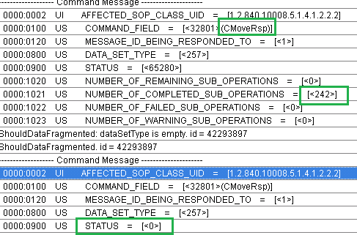

Understanding from iWatt Tool – Analysis Results

The same use case was executed and captured the communication through iWatt

Note: How to install and capture this communication can be found in the section-5, iWatt usage.

The beauty/advantage of this tool it will clearly shows the report with detail self-explanatory notes.
It really helps the new FSE/TSE who has very limited knowledge on DICOM can able to capture the logs and find out the potential problem.

Association Request and Accept is shown below between two DICOM nodes.

Association-RQ

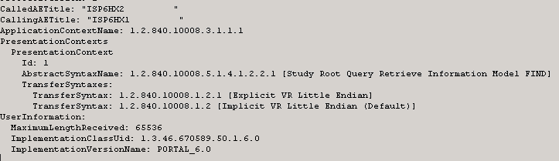

Association-AC

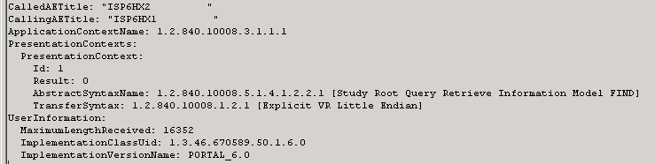

C_FIND_RQ: Queried for all CT studies.

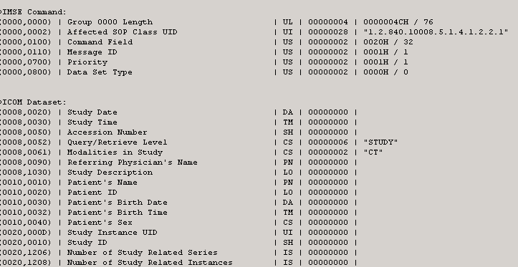

C_FIND_RSP – Responding for each study

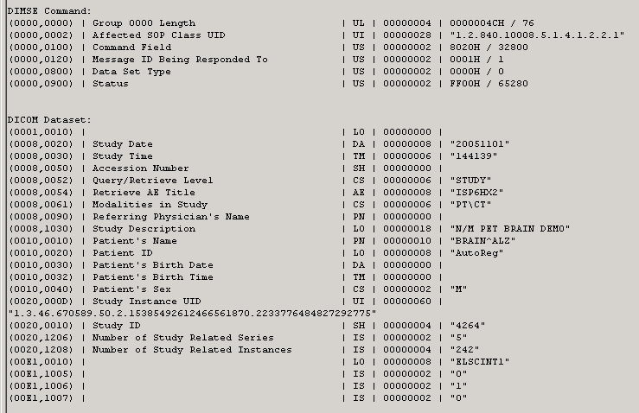

After all the studies were responded, final C_FIND_RSP

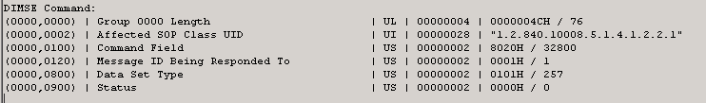

Complete Query / Find scenario is shown like this below for example query to get an overview.

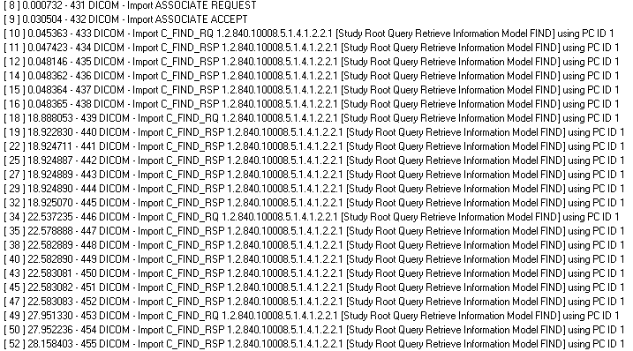

Move Operation related captured Screens.

Association Request and Response for study level MOVE operation.

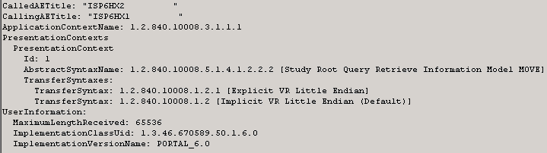

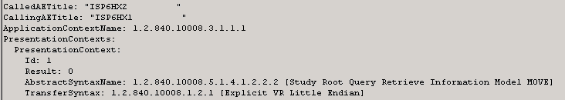

C_STORE Operation logs

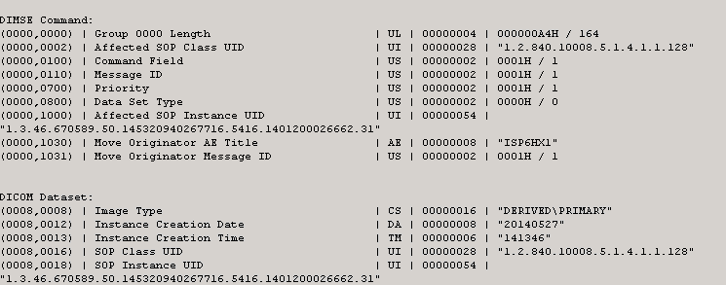

C_MOVE_RSP after all the images were transferred and it showing the success for status (0)
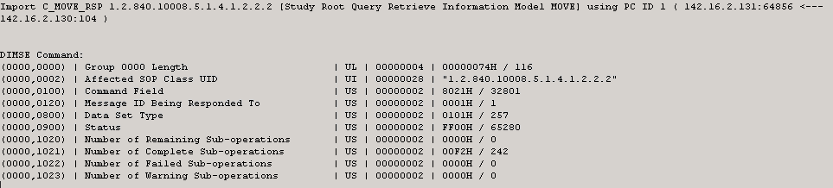

- Tips/Tricks in ISP for DICOM

  - DICOM Logging:

To capture DICOM related logging into the system, we have to enable the MXLLayer=Debug in the server side.
Below is the procedure to enable that logging.

- C:\PortalPms\System.
- Open “LogConfigurator” application.
- Change the mxlayer=”Debug”.

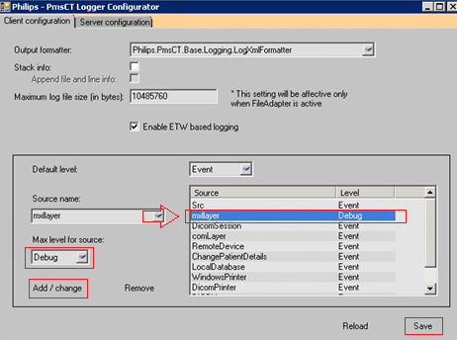

- Open the logviewer (C:\PortalPms\System\LogViewer).
- Perform the scenario and capture the logs.

NOTE: Always remember to change it back to Event level once capturing is done, otherwise unnecessary
Crashes and system behaves slowly during customer usage!

  - iWatt Usage:

- iWatt is the interoperability tool to capture the DICOM communication between two devices and also analyze the communication between two devices.

- It is one of the important tool which L2/FSE/TSE should use to capture the data and save the results
for analyzing the results.

Refer attached PPT for more details on the installation procedure and usage.

  - ViewDICOM Info:

In IntelliSpace Portal, if we wanted to see the DICOM fields and values if any for reference, there different levels at which it gives different detail of information.

In the Patient directory, choose the study

Study Level Info:

- Choose the Study and Right click on study; choose “View Dicom info” option.

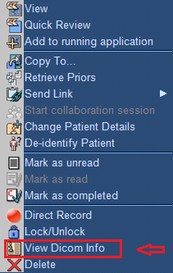

Series Level Info:

- To view series level information/series level DICOM fields, select any single series of interest
- Choose the “View Dicom Info”.

Image Level Info:

- To View Image level DICOM fields, Choose the series which is of interest and select the “Sub Selection” option in left side tool bar.



- Select any single image (Images List) and choose single image & right click then choose “ViewDicominfo”.

In Image viewing also, we can view some level DICOM details by using some options like
After opening the study in these viewers, there is button automatically opens up the DICOM info.

CT Viewer:

- Open study and click the button and it opens up the details.

MMV (Multimodality Viewer):

- Open study and click the button and it opens up the DICOM details.

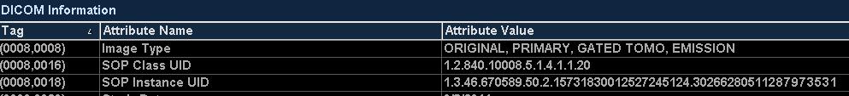

  - D4UI Tool

There may be some situations where in we have some DICOM files or folder which we have to open and check the
DICOM attributes of the image without viewing anything in the ISP.

There is a utility in the ISP server called

- Go to the path C:\PortalPms\System.
- Find “D4DUI” utility - .
- Once it opens up, drag the file into it and it opens the all the DICOM information which can be readable.

  - Viewers – Open Source:

There may be some situations where in we have to view the DICOM Files in some 3rd party software’s where
In to tell that is that ISP viewer is causing the issue or the issue with vendor who is sending the images.

Usually, once we capture the studies in the iWatt (version 6.0 above) /Wireshark (Version 5 or less) – then copy those files and use one of the viewer to make sure that is it the same issue reproducible.

- Philips DICOMViewer:

 http://www.medical.philips.com/main/about/connectivity/

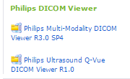

b. Sante Viewer:

http://www.santesoft.com/products.html

  - Important DICOM Tags:

5.6.1 Generic Tags

- (0010, 0010) – Patient Name:

Generally, Patient Name will have 5 components in DICOM, First Name, Given Name, Middle Name, Prefix, and
Suffix. All these components have to be embedded in single attribute with PN VR type.

“^” symbol is used to separate each component of the name.

FamilyName^GivenName^MiddleName^NamePrefix^NameSuffix.

(0010, 0010) PN – will hold these 5 components separated by “^”.

- (0008:0008) IMAGE_TYPE - It will tell what type of the series is of (ORIGINAL or DERIVED).
- (0008:0016) SOP CLASS UID: Tells which type of Image it is (CT/MR/US/etc.).
- (0002:0010) TRANSFER_SYNTAX_UID: It tells what type encoding was used to send this Study.
- (0008:0070) MANUFACTURER: It tells the vendor /manufacturer who made the studies.

5.6.2 Image Related DICOM Tags:

Image Width and Height: (Rows X Columns)
Their product is often referred to as spatial image resolution an equals the total number
of pixels in the image.
Samples per Pixel:

- Each pixel in the image has several sample values.
- Typical color pixel is a combination of RGB values, while the strength of each sample contributes to the pixels brightness.

Bits Stored: Depends on the color of image like monochrome and Color the number of shades matters, depends
On that, number of bits stored attribute is used and keeps the value accordingly.

Bits Allocated: Generally, the number of bits usually allocated upto multiples of eight (to fit into whole byte).

High Bit: The last bit number in Bits stored is called High bit and it is usually tells till where the bits stored under
Bits allocated value.

5.6.3 Query/Retrieve Filter:

While querying the PACS/large archive device, we see the standard DICOM fields which we can query to the PACS.

The list of fields which we can query is shown below and more importantly it is important to understand what
Each columns DICOM tag, VR, VM, Type of tag and more importantly what are permissible values for each tag.

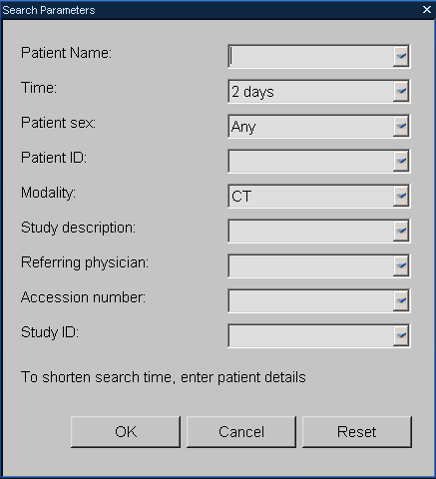

Field | DICOM Tag Name | VR | VM | Permissible/Allowed Values as per DICOM
Patient Name | (0010,0010) | PN | 1 | - 64 Characters Max it can have.  - Character set is defined in (0008, 0005) excluding control characters LF, FF and CR (Enter/Return).ESC character is allowed.  - “\” should not be used.  - It is combination of 5 components and each separated by “^”.
Time (Study Date) | (0008,0020) | DA | 1 | - “0”- “9”, in the context of a Query with range matching, the character “.  - Character “-“is allowed, and a trailing SPACE character is allowed.  - “YYYMMDD”.
Patient Sex | (0010,0040) | CS | 1 | - It can have “M”,”F”, or “O”.
Patient ID | (0010,0020) | LO | 1 | - 64 Characters maximum.
Modality (Modalities In Study) | (0008,0061) | CS | 1-n | - Uppercase characters, “0” – “9”, the SPCE character, and underscore “_”, of the default character Repertoire.
Study Description | (0008,1030) | LO | 1 | - 64 characters maximum.  - A character string that may be padded with leading and /or trailing spaces.  - It should have control characters (FF/LC) except ESC.
Referring Physician | (0008,0090) | PN | 1 | - 64 Characters Max it can have.  - Character set is defined in (0008, 0005) excluding control characters LF, FF and CR (Enter/Return).ESC character is allowed.  - “\” should not be used.  It is combination of 5 components  and each separated by “^”.
Accession Number | (0008,0050) | SH | 1 | -16 Characters maximum.  - “\” should not be there in the value.
Study ID | (0020,0010) | SH | 1 | -16 Characters maximum.  - “\” should not be there in the value.

These rules of DICOM will be very useful while troubleshooting the DICOM Query/Retrieve related issues from ISP to another ISP.

Note:
- Always remember the fact that, the results based on these DICOM fields listed above depends the PACS/ Remote DICOM node capability/support, if the PACS/DICOM device doesn’t support the searched DICOM field it may give all the studies or empty studies, It is always worth to refer to DICOM conformance statement of the vendor for the same.
- In Query/Retrieve DICOM service section above, we have mentioned the procedure to check the same in the DICOM conformance statement.

5.6.4 Prefetch:

- Prefetch is nothing but pulling the priors of one particular study (based on eligibility) from the PACS and keep it ready in the intellispace Portal.

- Technically, Prefetch is simply nothing but the Query/Retrieve operation by specific fields to the PACS and retrieving the studies to local just by automatically doing in the back ground without any user intervention.

- Most of the times, the most important thing to check in the Prefetch feature troubleshooting is that to analyze and verify in 2 Sections , Section 1, Prefetch eligibility section which checks the prior eligibility of study arrived and then if it is eligible brings up the section-2, which are the priors to be pulled.

- The areas to see, the Rule configured arrival study field values for eligibility, PACS capabilities/priors availability, and any un-supported series coming.

- Always take the rule configured and check manual Query/Retrieve to see if that working or not as I told the manual Query/Retrieve capabilities only automated via prefetch.

Other than this, the most important things which improve in understanding the prefetch issues to understand each DICOM field which is being used in the prefetch.

DICOM Tags which is used by ISP to query PACS

ISP Field Name | DICOM Tag Name
Modalities | (0008, 0061) - Modalities in Study  Note: This is a Study Level attribute and some PACS give all the studies if it doesn’t support.  There is something called Modality (series level) tag which is used by ISP during series level C_FIND_RQ to filter the exact priors during fetching process internally.
Body Part Examined | (0018,0015) - Body Part Examined
Procedure  Note: ( a.k.a Study Description) | (0008,1030) - Study Description
Series Description | (0008,103E) - Series Description
Study Date Range | (0008,0020) Study Date
Schedule Exam Date | (0040,0002) - Scheduled Procedure Step Start Date
Criteria for Identifying New Study | (0008,0020) Study Date value in the new study will be checked

At the PACS side, each DICOM tag support during query level and also the prior studies/series availability and those are supported in ISP also plays important level.

Always, checking same prefetch scenario, manual with query/retrieve and comparing the results would help to great extent.

5.6.5 Pre-Processing:

- Preprocessing is one of the coolest features of the intellispace portal in fact from Extended Brilliance workstation times.
- It can be triggered manually or automatically when the study arrives from any DICOM node and eligible based few rules pre-configured in the pre-processing.
- Always, after the series is arrived completed, around 20 to 30 seconds if no new series is coming, those series values will be checked against the pre-processing rules to see if that is eligible for pre-processing.
- The easiest way to check the pre-processing scenarios is to check first, if the study is eligible as per the rules configured and after that the results series were generated after algorithm is executed.

Below DICOM tags and rules will help in understanding the rules and permissible values should be available in the preprocessing rules.

- Mapping of pre-processing column names to DICOM tags :

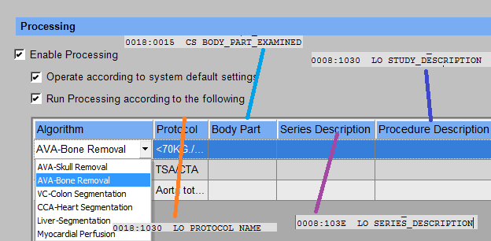

- DICOM standard rules for pre-processing rules:

S.No | DICOM Tag Name | Type | VM | VR | Length-Limit | Permissible Characters | Remarks
1 | (0018,1030) – Protocol_Name | 3 | 1 | LO | 64 Characters Maximum | - Character String(leading/trailing spaces)  - No Control Characters  ( Line Feed, Form Feed ,Carriage Return, Escape)  - The character code 5CH (the BACKSLASH "\" in ISO-IR 6) shall not be present, as it is used as the delimiter between values in multiple valued data elements. | - User-defined description of the conditions under which the Series was performed. Note: This attribute conveys series-specific protocol identification.
2 | (0018,0015) – Body Part Examined | 3 | 1 | CS | 16 byes maximum | - A string of characters with leading or trailing spaces (20H) being non-significant.  - Uppercase characters,"0"-"9", the SPACE character, and underscore "_", of the Default Character Repertoire
3 | (0008,0015) – Series Description | 3 | 1 | LO | 64 Characters Maximum | - Character String(leading/trailing spaces)  - No Control Characters  ( Line Feed, Form Feed ,Carriage Return, Escape)  - The character code 5CH (the BACKSLASH "\" in ISO-IR 6) shall not be present, as it is used as the delimiter between values in multiple valued data elements.
4 | (0008,1030) – Study_Description | 3 | 1 | LO | 64 Characters Maximum | - Character String(leading/trailing spaces)  - No Control Characters  ( Line Feed, Form Feed ,Carriage Return, Escape)  - The character code 5CH (the BACKSLASH "\" in ISO-IR 6) shall not be present, as it is used as the delimiter between values in multiple valued data elements.

Note:
Type: 3 mean that, this tag is Optional. May or may not be included and could be zero length.

Value Multiplicity (VM): 1 means that, it can contain maximum one value for this tag.
Value Representation (VR): Value Representation is like data type which tells what kind of data it can
hold in DICOM standard.
Character Repertoire: The default repertoire for character strings in DICOM shall be ISO-IR 6).

5.6.6 Data Synchronization:

- Data Synchronization is simply is to transfer studies from one ISP server to another configured ISP server based on
configured rules.
- Below are the DICOM fields which are used to configure the rules and getting to know about these rules would help in
Troubleshooting of this feature.

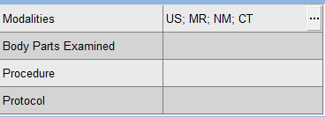

S.No | DICOM Attribute | Column Name | VR | VM
1 | Modalities | (0008,0061) | CS | 1-n
2 | Body Parts Examined | 0018,0015) | CS | 1
3 | Procedure | (0008,1030) | LO | 1
4 | Protocol | (0018,1030) | LO | 1

Always, compare with values arrived in the study for eligibility and see that it matches to be transferred during the off peak time as per the configuration with logging messages during the first trigger time would give good data of the issue.

  - Filters – LAN Config:

During DICOM export/ import from the ISP, we have some different level of filters which makes like change the image format/ block sending specific image types or change the format while sending or alternative we can apply the filters while importing as well.

ISP provides different Export, Import and blocking filters in addition to different filter options.

During, ISP support activities , it would be also worth to have quick check if any specific setting would help in fixing quickly.

In the LAN Config, click on the Advanced Filters option would take to the filter window; click the “Help” for more options.

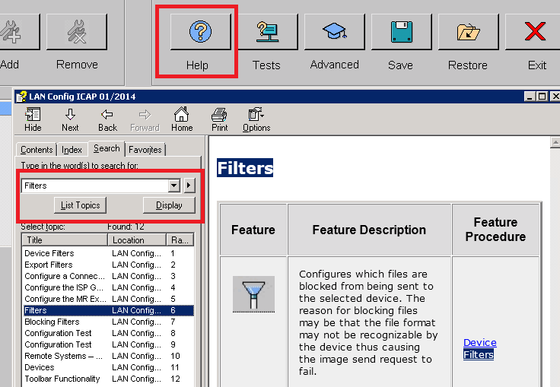

  - Image Types – Explained:

Generally, very broadly the type of formats the DICOM stores is two

- DICOM Specific:

- This is traditional way of representing since the starting of the DICOM standard.
- It is similar to BMP with slight variation in packing the pixel bytes.

A typical CT – 512 X 512 Image will have multiplication of these values pixels and stored in a file
Once it is acquired and generated image in the scanner or workstation.

Below are DICOM tags which influences the way the image is stored and interpreted actually.

  - Image Width and Height: ROW X Columns of image is total number of pixels in the image.

  - Samples per pixel: Each pixel can be blend of several sample values, i.e., mix of RGB values and mix/match of different values gives the greyscale to see the information in the image. For example 2 byte samples are used, it can give 2 2×8 = 65,536 possible grayscales.

  - Bits used to store a pixel sample: “bits stored” – always multiple of 8 should be allocated (because of byte is of 8 bits). This value shows how rich is your image is.The more the number, the more the quality of the image.

  - Bits Allocated per pixel Sample: It is also multiple of 8 and this shows much computer memory will be used to store a pixel sample.

  - High Bit: This will see in a minute, this bit corresponds to the end of the pixel sample with in the segment.

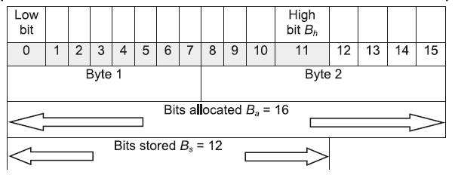

To summarize, below are important DICOM attributes of image in the Data Dictionary.

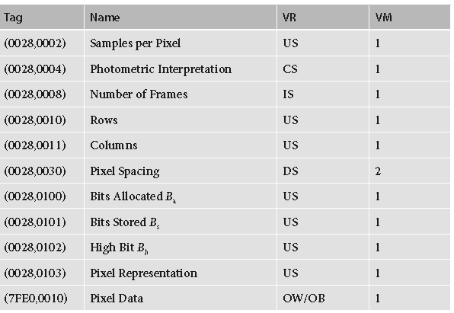

- Independent Standard formats (Accepted by DICOM):

- JPEG, RLE (Run-Length Encoding), ZIP, JPEG2000, JPEG-LS. – All these associated with compression.

Compression:

Consider a typical CT image with image width = height = 512, grayscale (one sample per pixel), and bits stored = 12. How much computer memory would it take to store this image? Well, let’s do the math. For storing 12 bits, 2 full bytes (16 bits) need to be allocated. The total number of pixels is 512 × 512, so the total number of bytes to store them will be: 512 × 512 × 2 = 524,288.
So, we would need half a megabyte for the pixel data stored in the (7FE0, 0010) “Pixel Data” attribute of the DICOM CT object. However, the CT images do not come alone; they come in series and studies, each containing anywhere from a few hundred to a few thousand images. In our case, a mere 200 CTs will occupy 100 MB.

Given this, image compression has been included in the DICOM standard since its inception. Image compression targets the (7FE0,0010) image pixel bytes and cleverly rearranges them into a much shorter form.

Typical image sizes for each modality type
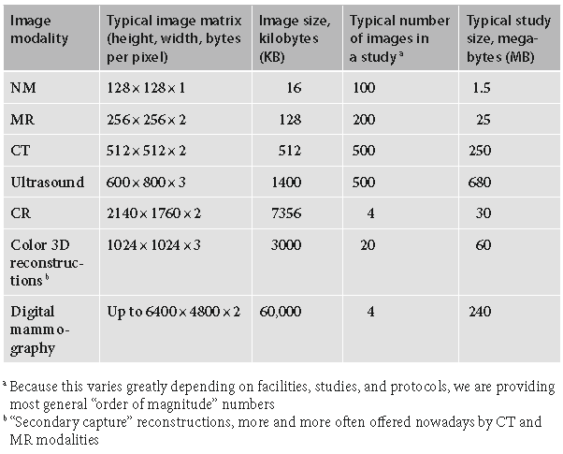

DICOM includes nearly all well-known image compression algorithms such as RLE, JPEG, JPEG2000, JPEG-LS, and ZIP. All of these algorithms have been developed separately, resulting in separate International Organization for Standardization (ISO) standards and applications; DICOM simply adopted them. All DICOM data objects with compressed (7FE0,0010) pixel buffers are encoded with an explicit VR Little Endian type.

Below are kinds of image series which we see in ISP, let’s explain what each means to us during our
Support activities.

Original:
Original series is nothing but series which is actually acquired in the Scanner/modality and it is the valuable and most important for any clinical applications to work properly.

Any vendor systems, which create the series of particular organ, should store all the images under image type as “Original”.

Generally, technologist’s sends only thin Slices to workstations and thick slices to PACS, because of two main reasons.
    - Thin slices makes large amount of memory.
    - Thin slice transfers consumes large amount of memory.

As we know the fact, nobody can change original raw content in it, only the encoding will change while transferring and the same encoding rule will communicated via Transfer Syntax as explained in DICOM communication and association section.

In ISP, at series level you will have column called “type”
For original series, it displays “ORIGINA” and also we can see what that series is all about under “Description” column like in this example, CT Surview 180.

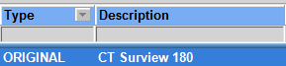

Alternatively, we can check the “IMAGE_TYPE” tag

The first word is important for this tag to see is it original or something else.

Derived:

    - Derived series is nothing but the results/post processed series generated from any clinical applications/review applications by technologists/Radiologists for diagnosis purpose.
    - These derived results are derived from the original series itself and all the content is made out of original by including some specific derived attributes with all post processing annotations kept on the derived series.
    - It can be in original SOP class or Secondary Capture SOP class.

In ISP,

Generally, only one doubt we get is that, where it is created (who), when it is created, what kind of SOP Class it is, etc.. During troubleshooting

Below attributes helps in understanding the Derived little bit more actually.

What type of Series is it?

Which vendor created this Derived Series ?

Which Product version Created it ?

When it is created?

This helps really understanding, the original source of data creation to understand in DICOM transfer troubleshooting issues.

Files (Non DICOM Files): When we save image types as BMP/JPG/AVI formats in our applications, it will store in this tab and these can be exported to client side drives and this can’t be transferred over DICOM. This feature is used in especially in teaching purpose by Rads to showcase in trainings/seminars/workshops actually.

Reports/ Encapsulated PDF:

All the approved reports in portal will be stored as DICOM “Encapsulated PDF” format which can be exported to the any DIOCM Node (like PACS). Always, check for destination DICOM node conformance for their conformance like if that supports the DICOM Encapsulated PDF or not?.

Raw Data:

Generally RAW data field has the files of RAW data of NM modality or Philips MR Scanner keeps some private series like Exam card Blobset, SeriesBlobset Information and these series will be converted to RAW data by the MR Scanner before sending to ISP (in fact any DICOM node), this series will be only understand by Philips MR Scanner and only once it receives back, will convert back to original private format.

ISP Specific Image Type:

Bookmark Series:

- Bookmark is kind of the state saving mechanism for technologists/Radiologists to save the state of the patient analysis just in case they have to switch to any other work or hold for some time.
- It is something similar to Presentation state.
- It is proprietary feature of IntelliSpace Portal which is carried over from the EBW product line.
- Once the book mark is created it will be shown like in the bookmark section in the ISP patient directory.
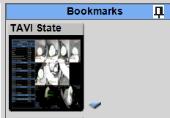

- Always remember that, the bookmark will not be shown under as one series in the series column.
- When exporting the bookmark to any DICOM node (other than ISP), will not know that it is a bookmark as it is proprietary to ISP and it will considered as just like another secondary capture series and while trying to launch it doesn’t load in those applications.

- Once the ISP brings back, it considers as bookmark and able to understand the same.

- While launching the bookmark series always remember that, the bookmark referenced original series should be available, otherwise it will error out.

- DICOM info Tags to Check for identifying the Bookmark Series /Image

SOP Class UID will be always Secondary Capture

It is also good to see the Image Type tag value which will have PHILIPS_BOOKMARK (could not be always for older application bookmarks)

There will be bookmark specific Tags which are private DICOM tags

  - Enhanced Objects Handling in ISP:

In IntelliSpace Portal, started support Enhanced objects started from ISP 5.0 onwards.

In ISP 5.0 – Support for Enhanced CT.
In ISP 6.0 – Enhanced and Enhanced MR started.

For Enhanced CT and Enhanced MR, the approach taken by ISP is important to remember during the support activities.

ECT to CT:
      - Whenever, the ECT is pushed to/brings to ISP, the Enhanced CT image will convert to Classic CT objects and stores only the converted classic CT images and the original ECT image will not be stored actually.
      - The converted CT images will not be transferred by default to any external system (as ISP should be treated as a converter box).But, if the hospital want’s to change it, they have to explicitly choose the option.

EMR To MR:

Please find the detail document explaining the EMR to MR Service guide for clear understanding.

  - Conformance Statements (DICOM & IHE) – Usage:

As L2/FSE/TSE, we always wants to know/ asked to be answered these questions like

- What is modality or type of modalities supported in ISP?
- What are transfer syntaxes supported in ISP?
- Does it support specific SOP Class like (Storage Commitment as SCP)?
- Does it convert the images for any specific modality (like for example ECT/EMR)?
- What are default association timeout values of ISP?
- What are specific error codes and it’s meaning w.r.t ISP?
- How specific DICOM service is handled like for example How the Q/R as SCU works in ISP?
- What are IHE profiles supported by ISP?

And so on…

The best bet would be to refer the DICOM Conformance statements and IHE integration statements.

DICOM - http://www.healthcare.philips.com/main/about/connectivity/dicom_conformance_main.wpd
IHE - http://www.healthcare.philips.com/main/about/connectivity/ihe_conformance_main.wpd

Alternatively, these can be found in the InCenter for each product version Reference section

  - Healthcare Standard Questions/Support:

- As we know that, DICOM standard is vast and it requires some good solid experience in dealing with all the standard implementations, verification, validation cut across all the products.

- In our Philips Healthcare, the team responsible and takes care of DICOM compliance across the various product portfolio is the IOCC (InterOperability Competency Center).

- They are the certified people who represent Philips in DICOM standardize committees to make the necessary changes and educating the BIUs in incorporating the same in products.

- For any questions related to DICOM, IHE, aspects can be addressed to below email ID, even iWatt tool as well.

dicom@philips.com

  - DICOM Troubleshooting – Checklist:

During DICOM scenario trouble shooting, we spend some good amount of time and we couldn’t able to find the cause of the problem, before we go and pull-in next level expert team (L3 /Engineering), it would be worth to collect these below information to help them in understanding the situation better for faster customer service.

These may not be complete exhaust list of things which solves the issue; but, it really helps to narrow down the issue.

Check Point -1: Document clearly the scenario/ issue like use case, what are DICOM nodes
(Scanner/PACs), Modality (CT/MR/NM/US/etc.), Vendor, Any Specific details of data.

For example,

- Query/Retrieve of MR data from care stream PACS fails in the middle of transfer.
- Unable to launch any study in the PACS Plug-mode (GE Centricity) and it hangs at 75%

Check Point-2: Try to narrow down the use case to specific DICOM Node based or Data Set Specific or
Generic Issue like happens for all the DICOM nodes.

For example Q/R fails for specific node, try with other DICOM nodes or try to send the same studies from the PACS instead of Q/R, try with different modality/study/data or try pushing fresh data from ISP and Q/R the same data.

Try all the combinations and document the same while escalating or reporting to next level.

Check Point -3: Collect below stuff

- Collect the logging (MXLLayer=Debug ) at the server side when the scenario failure and
Capture the all the error codes/error messages shown at the ISP side.
- Collect iWatt tool captured data (ISP V6.0 above) or Wireshark packet communication for V5 or less.
- Screenshot of the DICOM node configuration (Advanced settings) showing the AE, Port and all the settings.
- Connection and Configuration - Pass/Fail – Screenshot.
- If it is any feature (Prefetch, Data Synchronization, Preprocessing), take the screen capture of the rule from the preferences section.
- Collect dataset specifics like Manufacturer, Modality, Image type and Number of Series/Images – If possible anonymized data if it is proved to be dataset specific.

Check Point -4:

Extra information from the environment

- Changes at the site in ISP side or DICOM node side – discussing from PACS Admin of site.
- Before trigger condition – any specific changes in the network/IT side at the network.
- How the same DICOM Node is working w.r.t same scenario/data with any other DICOM node?

- Healthcare Standards – Overview

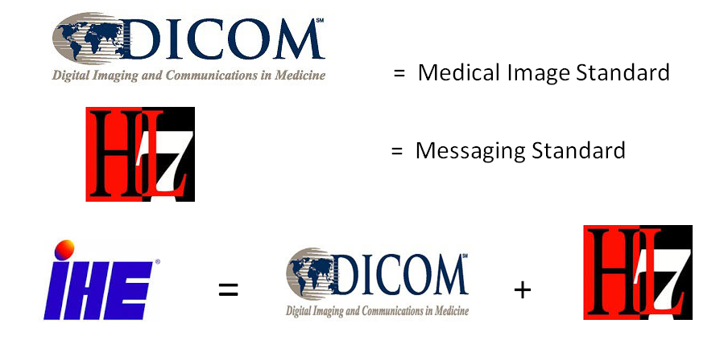

As we were discussing about DICOM from page # 1, I won’t bore again with DICOM
Let’s talk about HL-7 & IHE.

6.1 HL7 (Health Level 7):
- HL-7 and its members provide a framework/related standards for the exchange,
Integration, sharing and retrieval of electronic health information.

- These standards define how information is packaged and communicated from one party to another, setting the language, structure and data types required for seamless integration between systems.

- HL7 standards are used mainly between HIS, Departmental Information systems (RIS, CIS, etc.,) EMR, EHR.

- Though HL7 3.0 version is available, most of the systems in the field still use HL7 2.3/2.4 as base standard.

For more short training, there is 30 minutes training video in below link for your reference.

http://www.hl7.org/documentcenter/public_temp_B2352993-1C23-BA17-0C1DF80C55B397BA/training/IntroToHL7/player.html

6.2 IHE (Integrating Healthcare Enterprise):

- IHE is an initiative by healthcare professionals and industry to improve the way computer systems in healthcare share information. IHE promotes the coordinated use of established standards such as DICOM and HL7 to address specific clinical needs in support of optimal patient care.

- Systems developed in accordance with IHE communicate with one another better, are easier to implement, and enable care providers to use information more effectively.

- IHE defines profiles which each system adhere to it and implement those in the systems.

- These IHE profiles will be verified/validated in the international testing events called “Connect-A-thons” which happens in European every year.

- Different vendors come under one roof for one week and test among each these profiles and claim the conformance of the same.

- IHE monitors validate the results and once these profiles are passed, they provide the IHE conformance statement.

- ISP, IHE conformance statement can be found in below.

http://www.healthcare.philips.com/main/about/Connectivity/ihe_statements/workstations_statements.wpd

Also, available in the InCenter

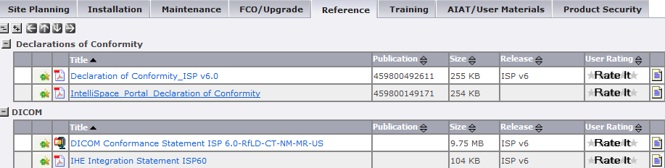

The DICOM Conformance and IHE conformance are good customer showcase documents to showcase the intellispace portal capabilities w.r.t Interoperability aspects.

- References:

Medical Standards – official link

http://dicom.nema.org/
http://www.hl7standards.com/
http://www.ihe.net/

Other Links:

https://groups.google.com/forum/#!forum/comp.protocols.dicom
http://www.dclunie.com/
http://dclunie.blogspot.com/2009/04/to-push-or-to-pull-that-is-question.html
http://www.li.mahidol.ac.th/e-resource/ebook/DICOM_Basics/swf/B-105_docs.swf
http://dicomiseasy.blogspot.com/search/label/DICOM?max-results=7
http://www.sno.phy.queensu.ca/~phil/exiftool/TagNames/DICOM.html
http://ihewiki.wustl.edu/wiki/index.php/Installation_Guide:_Windows_/_Binary
http://www.dclunie.com/medical-image-faq/html/
http://dicomlookup.com/
http://www.sno.phy.queensu.ca/~phil/exiftool/TagNames/DICOM.html
http://support.dcmtk.org/docs/index.html
http://godzilla.kennedykrieger.org/dicomfiles/#dicom3tools
http://www.dicomtags.com/iods/index/page:40
http://www.li.mahidol.ac.th/e-resource/ebook/DICOM_Basics/swf/B-105_docs.swf
http://www.pacsmule.com/pacs-news-feeds.html
http://caristix.com/blog/2012/11/the-hl7-survival-guide-introduction/
http://www.hl7.org/documentcenter/public_temp_B2352993-1C23-BA17-0C1DF80C55B397BA/training/IntroToHL7/player.html

****************** HAPPY ISP SUPPORTING **********************

